Unit 8:

Recruitment and Selection Process
Learning Aim, A:
Examine how effective recruitment and selection contribute to business success

Name: __________________


Staff turnover

Fixed term contract

Probationary period

Head-hunter

Opportunity cost

Person specification

Psychometric tests

Recruitment of Staff
There are lots of different reasons why an organisation may decide to ______________ someone to a ______________. One of the most common that you may have heard of is that someone is leaving to go and work for another organisation and their position needs to be filled. Large businesses carry out __________________ planning to find out if they need to recruit anyone at all.
Workforce Planning
Businesses need to match the ______________, ______________ and number of ______________ to their current and future needs. To work out their needs, they need to ______________ the number and skills of employees they have now, what they think will happen in the future and the number that they will need in the ______________.
In large organisations with more than 250 employees, the types of skills required will depend on the ______________ that they work in. For example, a retail business may need staff to put out stock and to serve customers face-to-face. A production company may need staff to work in packing or on the production line. A financial organisation may need staff with _________________ experience and __________________ to offer advice and maybe telephone ______________.
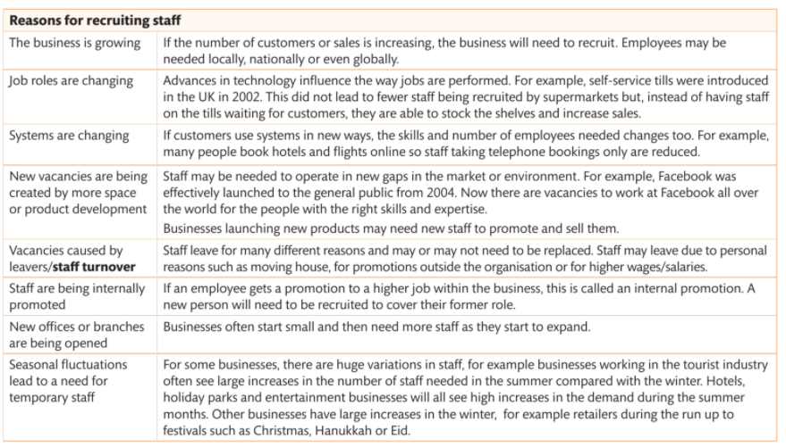
Reasons for Recruiting Staff There are lots of reasons why businesses will need to recruit staff. Businesses often recruit due to a mixture of some, or all, of the reasons that are shown below.
Job Centres and Agencies
An organisation may not able to manage the process of _________________ themselves because they are too busy or feel they do not have suitably qualified staff to run the recruitment process. They may use job centres or other agencies. Job centres are popular places for employers to advertise vacancies as this is where people go to get advice on different jobs and ______________. Job centres work with employers to provide additional ________________ and ______________ to local area so that employees can be found to fill _________________. Job centres are also able to offer employers extra training and support so they can recruit employees, for example, by giving advice on recruitment or on different training opportunities such as apprenticeships. Recruitment agencies such as Reed or Office Angels are also popular but, unlike the job centres, they charge _________________ for finding suitable people for employers on a temporary or permanent basis.
Recruitment ________________ provide employers with details about potential applicants. Often recruitment agencies will provide staff on a ________________ or ________________ basis. This means that an employer may have a chance to see have an employee is likely to work out by putting them on a 3, 6- or 12-month fixed term contract initially. This is often a cost-effective option for employers, particularly if their business changes rapidly and they may not need to keep staff permanently. Also, almost all jobs, whether permanent or fixed-term contracts will have a ___________________ period.
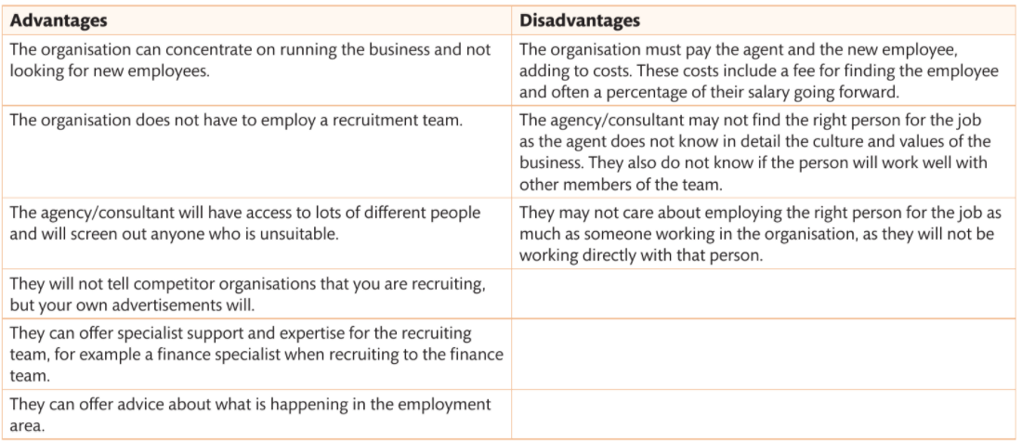

Pause Point- Case Study
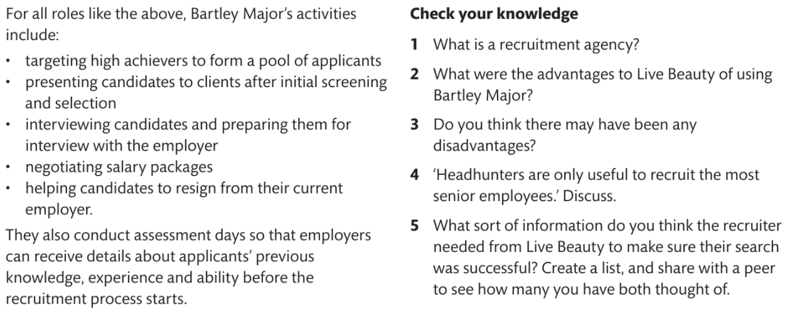
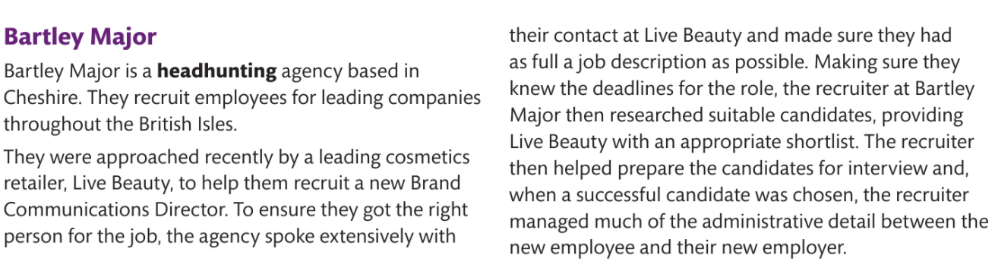

Internal Advertising Compared to External Advertising
Jobs can be advertised _________________ or ________________. Internally advertising means that the advertising of the job will only be done inside of the organisation. This means that the person will already have an idea of the type of _________________ that they are working for and the skills needed to work there. Sometimes, this type of advertising and _________________ will also give current employees the chance for promotion or additional responsibility, so it can be _________________ for them.
Organisations will sometimes decide to advertise a ______________ internally first. If no suitable employees apply for this job, they will advertise outside as well. Of course, if a vacancy is advertised internally and someone changes jobs to fill the role, somebody new may be needed to ______________ them, in turn. This may ______________ the __________________ process and may be a problem for the organisation if they need recruit quickly.
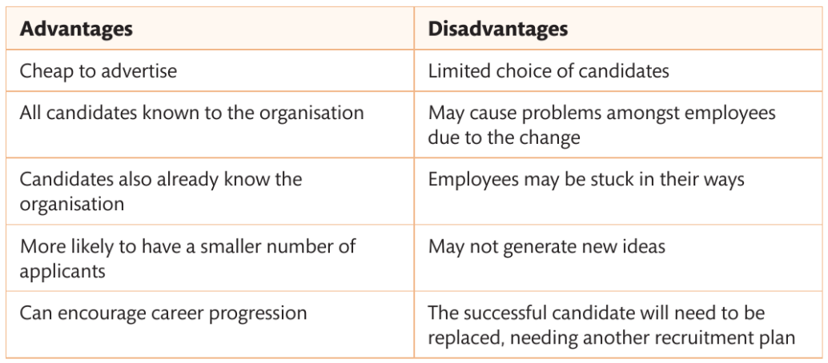
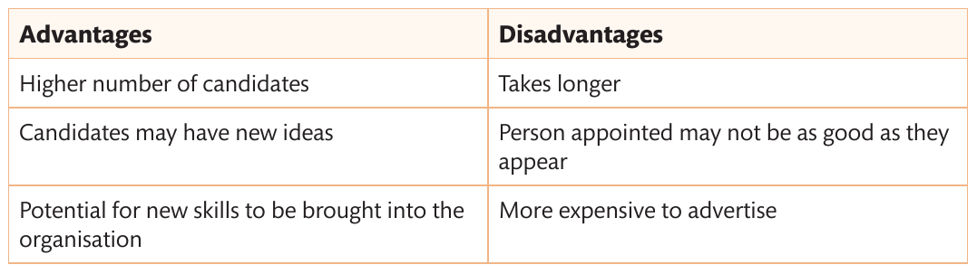
________________ _________________ is the opposite of ______________ and is the process of recruiting from outside the organisation. There are a number of ways this can be done and these include organisation itself doing the ________________ or making use of job ______________ and agencies.

Online Recruitment and Traditional Methods
Many businesses now make use of online methods to recruit staff rather than traditional advertising such as shop windows or in the local newspaper. Online methods include:
- ______________ ______________ such as Facebook and Twitter
- ______________
- __________ ________________ ______________ to be filled in onscreen.
- Emailing completed forms or ________________ ______________ (____)
Traditional methods are those that have been used for many years including:
- ______________ _____ for a discussion or informal chat
- Sending in a paper ______________ ______________
- ______________ _____ ___________ _________________ to be sent in by post with a CV.
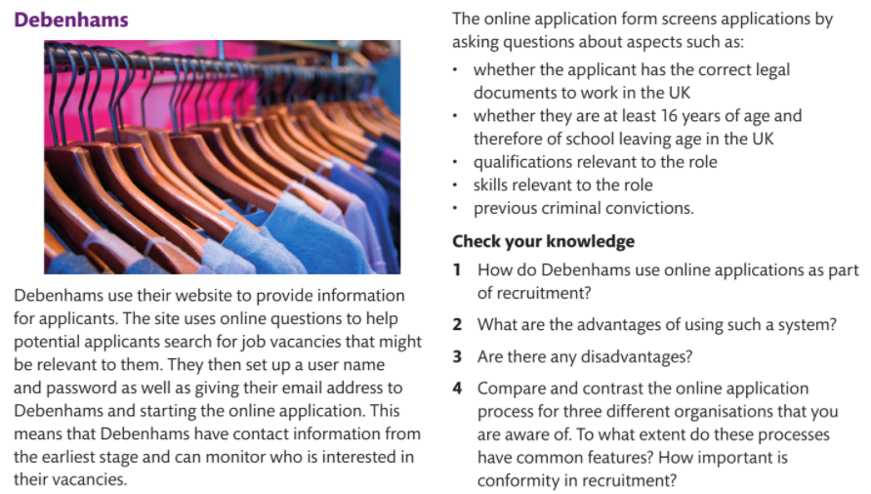
Pause Point- Case Study

Pause Point
Can you explain what recruiting staff means? Can you explain the difference between internal and external recruitment and the difference between online recruitment and traditional methods?
Hint- draw a table showing the differences between internal and external recruitment, with examples.
Extend- when is online recruitment used more than traditional methods for internal recruitment and why?

Recruitment and Business Success
Recruiting the ______________ ______________ is very important for the success of a business. Often people are the most ______________ ______________ in a business and employing the wrong people can be costly if customers are unhappy or receive ______________ ______________. Each time a business recruits a new member of staff there is a cost to the business. This is called an ______________ ______________. This is the cost of the advertising and recruitment process itself but also the cost of the opportunity (because the time that the hiring manager spent on recruiting could have been elsewhere in the business). Good ______________ lead to high numbers of applicants and, ultimately, a good choice of people to work for the business. Poor recruitment has the opposite effect and can lead to the business be short of staff and unable to work ______________.
Professional Recruitment Leading to Efficient Staff Integration
Recruitment staff in a ______________ way is also critical to businesses and helps their success. This is because professional recruitment means that the ______________ of the business continues to be good so more people be attracted to work there.
Professional recruitment also ensures the new staff fit into the culture of that business and quickly have a ___________ impact on the business because they are ___________ of what is required for the business at the very start of the process. This means that staff become ______________ more quickly, leading to efficient working practices.
Recruitment and Selection Process
The two elements of the recruitment and selection process are:
- ______________ the documents that are needed for recruitment from the advertisement, including arrangements for applicants to send in their information to the business.
- ______________ of the candidates once applications have been received
The Recruitment Process
You have already learned that advertising can be internal or external and the same is true of all other elements of the recruitment process. Businesses often use different documents for internal recruitment compared to external. This is because they ___________ _________ _______ ______________ that are involved. Some businesses may ask employees to ________ ___ __________rather than filling in an application form for internal vacancy.

Job Advertisement
Internal advertising is the simpler of the two types of advertising for a vacancy. This is because it only needs to be shown to employees who currently work for the organisation. It may be placed on the staff noticeboard, webpage, company magazine or mentioned in a staff meeting or through a mass email. The details of the job need to be given, together with any increase in _______ or _________________. All members of staff can decide whether or not they want to apply. Organisations sometimes ask employees to provide a ‘_____________ ___ ___________’ for a vacancy. This means that they write a letter to their employer or speak to their employer about why they are interested in a particular job. The employer can then see how many potential people would apply for an _____________ job and make a decision as to whether this is the best way to recruit. They often also ask that any potential _____________ inform their current manager of their interest in another role.
External advertising is more complicated as it can be achieved in a number of different ways. Some organisations use _____________ or ________, others a ____________ in the window, so keep an up-to-date list of interested people to email and others rely on
industry related _____________or _____________. Online advertising through websites is becoming increasingly popular. In short, the most suitable place to advertise a post is with _____________ applicants will read it, so this can vary by sector depending upon who your likely pool of candidates is. Advertising, as you have already learned, may also be done by using an agency or job centre.
One of the _____________ methods of advertising a position is a _________ in the window of a business or on a noticeboard. You may have seen this type of notice when you were looking for a part-time job. Employers will put it in the window and anyone in the local area will see it and then may decide to apply. Any applicants will already have some information about the company. This type of advertising does _________ the number of possible people applying, because only those who have been passed or into the organisation will see it. This type of advertisement may seem _____-________________ but it is still relevant for certain types of work.

Job Analysis
The job advertisement is one of several documents needed for the recruitment process. As soon as an advertisement is placed, potential applicants will want to __________ _________ about the job role so a job description needs to be written. Before businesses write this description, they often _____________ ______ ______ to review all the different parts of it and the type of person that would be able to perform the role _____________. Job analysis considers the:

Job analysis is used to create the job description and person specification that are required.
Job Description
Job description give information to _____________ employees about what the job actually involves by giving the purpose of the job and the type of _________________ and _____________ that will be expected as part of that job. Different organisations have their own particular extra information, but there are a set of key elements that are always included.

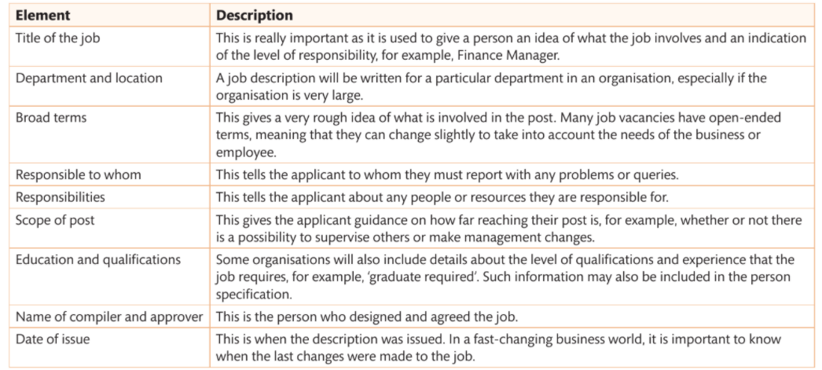
Elements of a Job Description

Person Specification
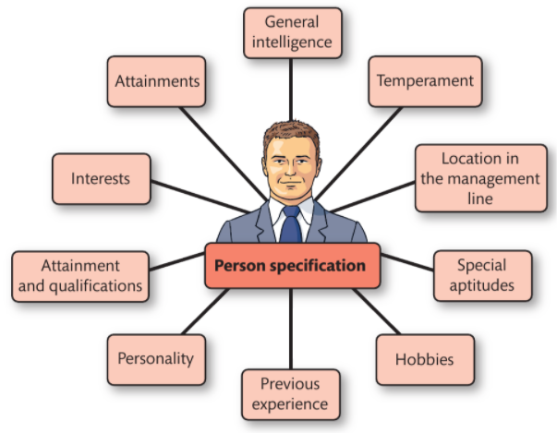
The job description essentially concentrates on providing information about the job. The person specification is a _____________ _____________. It provides information about the type of person that the organisation is looking for to do the job.
The person specification gives a list of requirements, but these relate to the person doing the job. It will have an introduction at the start giving details about the job, such as _______ ___________, post _____________ _____________ and management __________________ (including who the employee needs to report to and is responsible for). It will then detail _____________ that the organisation wants that person to have, for example, their type of personality or intelligence level. Often person specifications have a list of attributes that are considered to be _____________ or _____________ elements.
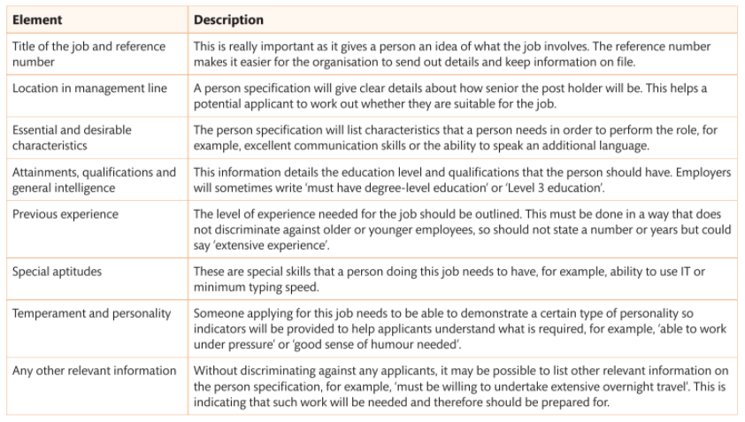
Elements of a Person Specification
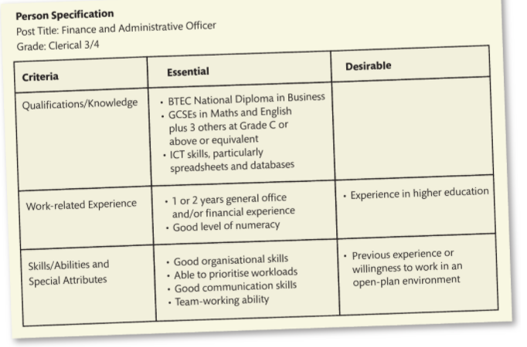
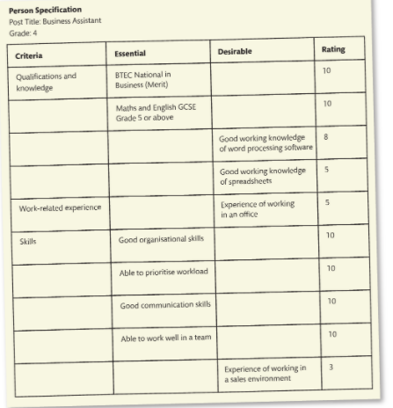
An Example of a Brief Person Specification

Pause Point
What is the difference between a person specification and a job description?
Hint- Think about the purposes of each document to help you remember
Extend- what would happen in the recruitment process if one of these documents was missing? What would the implications be for the business?

CV or Application Form
A CV (_____________ _____________) requires applicants to write all their details including education and history on a two-page sheet, including referees. The organisation can immediately see everything about an _____________. CVs only focus on positive aspects of an applicant, so it may be difficult to compare applicants. CVs may also have been used to apply for lots of jobs so may not be specific to a _____________ role. It is _____________ to review a CV regularly or to adapt it for each individual job if an applicant really want that job.
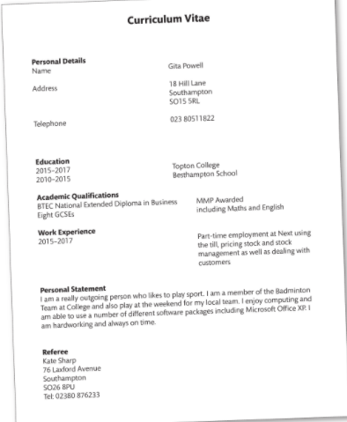
Example of a CV

Application Form
Application forms also require applicants to give their details but in a standard format that makes it easier for employees to compare applicants. They can be completed _____________ or _____________ _____________. The information in the questions can be directly related to the individual business needs, meaning that they can sometimes be of more use to a business to ensure they are getting the right _____________ for that specific job role. Paper application forms are sent out that and this means there are often additional ________ and _____________ _____________. Online application forms can save processing and postage time as part of online recruitment

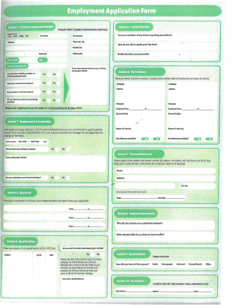

Letter of Application
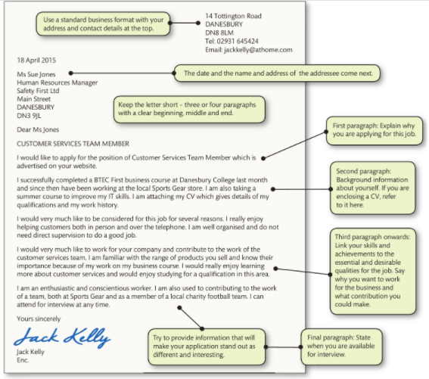

Letters are used by applicants to _____________ why they are _____________ for a job. Applicants can use a letter to highlight any special _____________ and _____________ they feel they have that make them suitable for the job. Applicants should use the chat description and person specification when highlighting their particular _____________ so that an employer can match them to the job.
Online Recruitment
Online applications are very popular. They take two main forms: the email application and the online application form.
- _____________ _________________ are very similar to the letter application but, instead of sending the information through the post, it is emailed, which is quicker. An email application may have the letter of application within the body text of the email or attached as a separate document.
- Some employers ask for _________ _____ __________
- _____________ may need to download and fill in an application form that can be sent as an attachment by email
- All these methods of time and postage costs, allowing businesses to make use of _____________ to become more cost-effective. Online applications mean that, rather than filling in an application to send in, the application is online so the information is sent to an online database and stored immediately. This method of application is very cost-effective for employers as data can be filtered automatically, reducing _____________ costs. It also reduces time spent on the process, for example, by not having to use agencies or staff members sifting through CVs. A _____________- _____________ example might be as an employer asking that potential applications have a Merit for BTEC National Business. When the online application reaches the online database, those detail will be automatically checked and, if the information provided does not match the specification required, then that application is immediately _____________.
Pause Point
What are the advantages and disadvantages of using application forms and CVs online and offline?
Hint- Compare the different types of paper applications and then online applications. Consider creating a table
Extend- consider one business and decide which application documents and methods would suit their needs best

Selection
The selection part of the recruitment and selection process refers to the methods used to actually choose the right person for the job. There are lots of different methods that can be used.
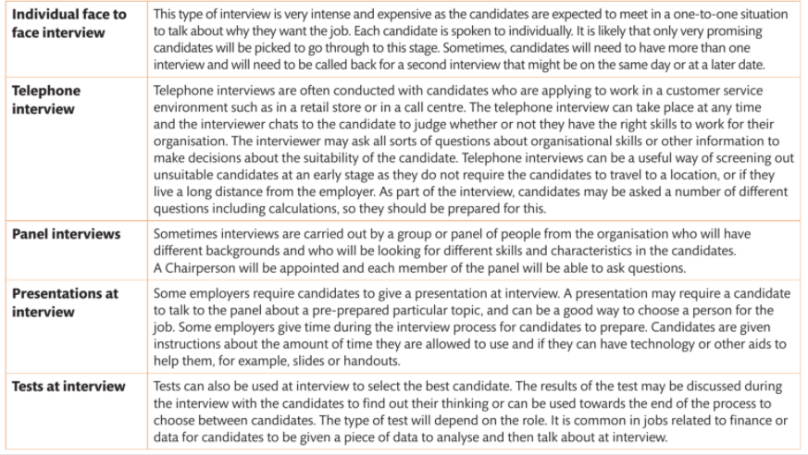
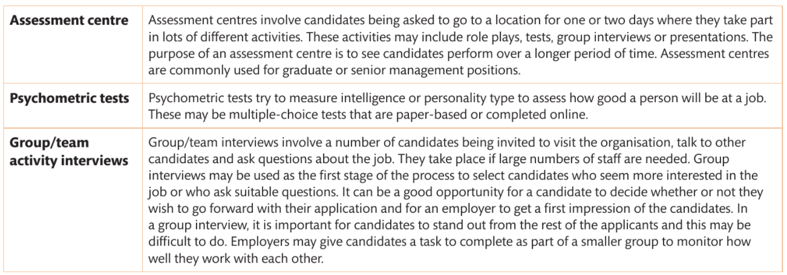
Summary Table of Selection Method

Interview Protocol and the Selection Process Used
Interviews need to follow interview _____________. Protocols are expected rules and guidelines that are not written down by the candidate(s) and the interviewer(s) are expected to follow. These may be things like:
- Candidates arriving at the interview _____________
- The need to _____________ _____________ with a _________ ________ ________ _____________
- The interviewers _____________ _____________with candidates when they enter the room
- The candidate _____________ _____________of their last or current employer and not saying bad things about them
- Candidates not eating during the interview including _____________ _____________
- At the end of the interview, the candidate _____________ the employer for the interview.
For different types of interview the protocols are slightly different and this does have an impact on the way that the process is run. The type of interview _____________ used is very important to make sure that the organisation recruits the right person and that the candidates are given the right impression of the organisation. The _____________ _____________ processes give candidates the opportunities to demonstrate their suitability for the job as well as ensuring that they leave the process with the very best _____________ of the organisation.
Assessment Centre
At assessment centres, candidates are usually given their meals throughout the day and overnight accommodation and breakfast if the event goes over two days. Candidates are _____________ during the _____________ _____________of the two days, for example during the interview, but also during the less formal stages such as during dinner or coffee breaks. Candidates need to be aware that they are being _____________ and judgements are being made throughout all activities and they should be _____________ at all times.

Advantages | Disadvantages
Psychometric Tests
Psychometric tests may be completed in a _____________ _____________, for example with the employer or with an agency, or many organisations are now asking candidates the complete them online at _____________. Psychometric tests can be used to test for different types of skills. Some psychometric tests make judgements about levels of _____________, for example in _____________ or _____________. Other types of psychometric test give information about the type of personality and working practices that a person has.
Advantages | Disadvantages
Group or Team Activity Interviews
The protocols for group or team interviews will vary significantly depending on the type of business that is _____________. This is because the skills that are required for those businesses will also vary significantly. If a person is being recruited to work in an office, for example in finance, the type of activity that is conducted will be very different _____________ with a group interview for a role in a customer service environment such as in a retail shop.
Advantages | Disadvantages
Pause Point
How would you feel as an interviewee during a group interview or team activity?
Hint- Think about the types of activities you might be asked to do.
Extend- What would you find out as an employer?

Individual Face to Face Interview
Face to face interviews carried out one to one are still one of the _________ _____________forms of interview. This type of interview will usually take place in the workplace. Candidates will usually wear _____________ _________ such as a suit.
Advantages | Disadvantages

Telephone Interview
Telephone interviews are commonly used when _____________ numbers of ________________ have been received. Telephone interviewing enables communication skills to be assessed. Sometimes telephone interviews will include _____________ that candidates have to complete, including mini tests.
Advantages | Disadvantages

Panel Interview
The protocols for panel interviews are again very different depending on the organisation. Often panel interviews only consist of _____________ _____________members but, on occasion, it can be as many as ten different people depending on the _____ _________ and _____________ involved. Panel interviews, particularly when they are large panels usually adopt _____________ _____________.
Advantages | Disadvantages

Presentations and Test at Interview
There are no set protocols for __________________ and _________ at interview. Each business will decide how and when presentations and tests are used. Sometimes candidates are asked to prepare a presentation in advance of the interview day and then be prepared to give that presentation. For other _________________ processes candidates are given the topic when they arrive. Tests may also be done in advance, usually _____________, or on the day, and candidates are often asked to discuss what they have found and be asked further questions about their _____________.
Advantages | Disadvantages
Pause Point
What are the benefits of a telephone interview compared to a face to face one?
Hint- Think about the different skills of communication required for each. Are telephone interviews ever not appropriate? Justify your answer.
Extend-What type of interview would be most suitable when employing a senior member of staff to work in a large finance organisation, and why?

Initial Selection Processes Using Screening
Selecting the _____________ person for the job from the candidates ________________ is a very lengthy process so this means it costs businesses time. Some organisations will use initial selection processes to _____________ candidates first before they take them through to be selected for interview. The screening will check skills, for example organisational __________ or other information, to make decisions about the __________________ of the candidates to go forward.
- _____________ _____________cut out times and costs for both parties by avoiding travel. Telephone interviewers often have a set of _________________ questions so the process may be completed by less _________________ interviewers and is more _________-___________________ for the organisation. As part of the interview, candidates may be asked a number of questions including calculations.
- _____________ _____________ _____________also ensure that the candidates are screened. These tests may be completed within strict timed deadlines to see how candidates work __________ _____________. They may test English, maths or other types of skills such as _____________ to detail or _____________.
It is really important that all section processes meet the needs of the business that is _____________, especially the initial selection, or the organisation may lose very good candidates at the early stages of the process who may have been good for the role. This is even more important in areas of industry where they are not enough skilled people in a particular field. An organisation will want to _____________ as many people as possible to be interested in their role and not be put off or excluded at the _____________ _____________.
Use of Technology in the Process
Technology has ________________ the way that employees are ________________, as you have already learned. It reduces costs and makes the process much faster through the use of _____________ _________________ forms and CV’s being uploaded the websites, compared with waiting for the post. Even ________________ ________________ of application can be enhanced using technology. For example, if an employer wishes to see an example of a candidate’s ________________, this can be scanned and then emailed or uploaded. It is important that technology is used carefully and appropriately for the role but, because _______________ is used in many roles, using it in the process of application can, in itself, test the _____________ of the applicants at the initial stage.

Pause Point
What are the benefits of a telephone interview compared with a face to face one?
Hint- Think about the different skills of communication required for each. Are telephone interviews ever not appropriate? Justify your answer
Extend-What type of interview would be most suitable when employing a senior member of staff to work in a large finance organisation, and why?

Communication with Prospective Employers
Communication during the selection process is also very important and this can be done easily through a variety of different methods:

It is important that the communication is _________, _________ and that applicants/candidates are kept _____-______-________ at each stage of the process. While letters are an excellent way of having a record of something that is set out, they take longer to send them an email.
On the flipside, a letter is often viewed as an _____________ and _____________ document compared to the email, which may be lost in a junk inbox all go ________________ if the applicant receives a lot of emails on a daily basis. Most methods using online or paper provide a record of the __________________ that can be reviewed at a later __________, if necessary. Telephone communication through voice rather text does not always provide a record unless the organisation uses voice recording as part of their protocols. It is very important that the _____________ of any selection process can be monitored to ensure that the organisation is providing the very best service possible and that, if any improvements need to be made, these can be _______________ and _____________ can be put into place.
Quality of the Process and the Documents
Recruitment and selection is very important to businesses because a _____________ _____________ process using good quality documents should lead to good _____________ _____________that join and stay with the business. If the process is week and the documents are poor, it is likely that the best employees will not be recruited and that some _____________ may not stay
Linking the Process to Efficiency and Business Success
Having the best process that requires the least amount of _____________ necessary to recruit the best employees should lead to business _____________. Often employees are the biggest expense for a business so having an _____________ selection process ensures that the correct amount of _____________ is spent on the process and also ensures that the right people are selected.
Ethical and Legal Considerations in the Recruitment Process
There are a number of _____________ and _____________ issues that you must consider in relation to the recruitment and selection process. Ethical issues are those not governed by ________ but which are considered as the right processes to follow to be fair and _____________ to all
It is important that employers are aware of the latest __________ __________________ legislation and ensure that they comply with it or risk prosecution. Most employers have a very equal opportunities _____________ to help them comply with the legislation, and also to ensure that they make changes to help _________________ employees from different groups to be successful in their applications. Try to think of the _____________ to employers or hiring a diverse workforce.

Ethical Considerations
Ethical considerations are slightly different to legal ones in that they include elements that are not required by law but, when implemented, they ensure that the process is fair, even if action could not be taken. These include considering:

Pause Point
What would the consequences be if an employer did not follow any of the above ethical considerations?
Hint- Think how you would feel if any of these ethical considerations affected you.
Extend-What could the consequences be for an employer that was found to be acting legally but not ethically?

Equal Opportunities Legislation
Equal opportunities legislation ensures that all prospective employees are supported to do their best and they are not disadvantage. The law that relates to equal opportunities change regularly and is updated. ________ _____________ _________ ________ensures that different groups of prospective employees are not discriminated against when applying for jobs due to any of the following reasons:

These reasons are _______ ‘_____________ _____________’ and, if discrimination does take place, a prospective employee can take action against an employer
It is also important that employers offer the minimum wage when advertising a vacancy. The _______________ ________________ _______ is an amount of money set by the government as recommended by the _______ _______ ________________. Each year the amount goes up, but it is the minimum amount of the workers aged 16 or over must be paid for doing a job. There are a few exceptions to this amount of money and specific rates are given for workers aged 16 and 17, as well as 18 to 21 and 22 or over. These amounts are the minimum rate that must be paid, but, of course, _____________ can choose to pay more if they wish.
If employees are not being paid the minimum wage, they can ring the ________ ________ _________ ____________ _______________ to report their employer and either give their name or call ________________
Employers must always ensure they are using the latest legislation and minimum wage rates during the recruitment process. Employers can face _______________. This is obviously ________________ to a business, not only due to the financial impact, but also due to their _______________ as reliable and honest business.
Right to Work Legislation
Employers must also make sure they are recruiting a person that they have the right to live and work in the UK. The law relating to working in the UK is complicated and changes frequently. Employers must make sure that they are aware of the law and that they asked for the right documents and information to ________ _____________a person that does not have the _____________ ______ ________ ____ _____ ______.
The government’s website has lots of information about the latest legislation but, essentially, the most critical information is to ensure that prospective employees have the correct paperwork such as letter from _______ _____________ _____________ ______ _______________ (HMRC) or a British or an EU passport, or documents on the Home Office proving their right to work in the UK. Employers must check these documents and ensure that prospective employees are allowed to work in their business. Employers must keep a copy of the document and ensure that they are within the required dates. If they do not check these documents, and employ someone illegally, the risk a fine up to _______________ per person as of August 2015.

Pause Point- Case Study
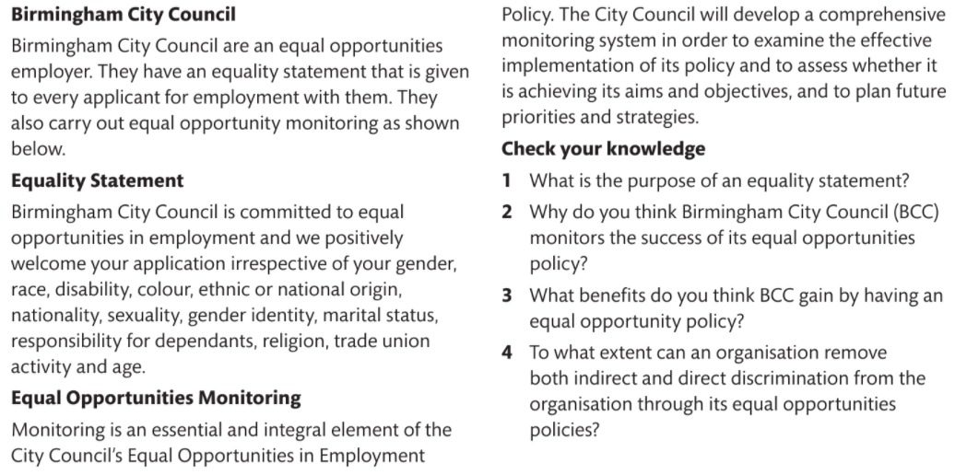



At the end of each page tick the box.
Red- you would like to go through the task again in detail
Orange- you would like to go through the task again- as a starter.
Green- Good understanding and do not wish to review it.

The idea behind the traffic light system is to check your understanding through each page.

The reason for each page is because there is a lot of information and sometimes it can be confusing.
Don’t worry, I am here to help. Remember you are not alone, if you don’t understand something the chances are someone else doesn’t either.

So, fill in the traffic lights and we can support each other in our learning.

