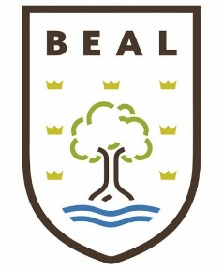
Department of Economics
Year 11 into Year 12 Summer work (Bridging Work)
Welcome to the Economics department. This booklet contains a variety of tasks for you to complete and submit on the first lesson in September. The purpose of these tasks is to familiarise with Economics and be ready to start the course.
You will complete the Pearson Edexcel A Level in Economic A - https://qualifications.pearson.com/en/qualifications/edexcel-a-levels/economics-a-2015.html
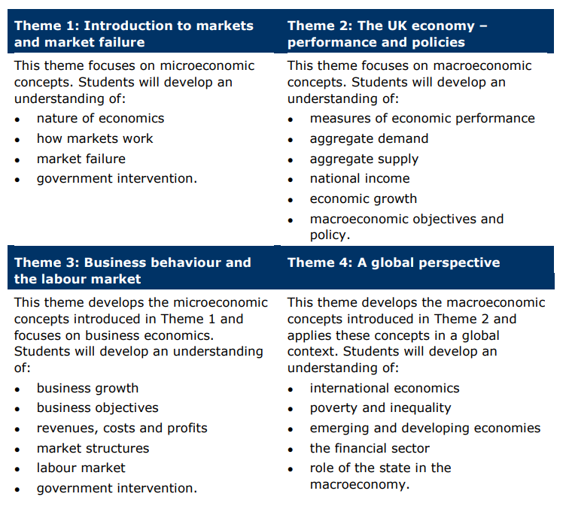
It is important that you have a look around the website so that you know how to access the specification, past paper, mark scheme and examiner reports – all vital for success.
Throughout the year there will be plenty of opportunities to enter yourself into national competitions and local competition. These are all brilliant experience and will support you learning and enrichment.

In preparation for your A Level in Economics, please complete the following tasks.

Task 1:
Watch the following videos:
- https://wetheeconomy.com/films/cave-o-nomics/
- https://www.youtube.com/watch?v=3ez10ADR_gM&list=PL8dPuuaLjXtPNZwz5_o_5uirJ8gQXnhEO&index=2
Answer the following questions:
- What is economics?
- Why is economics important to society?
- How does supply and demand effect markets – can you draw a supply and demand diagram.

Task 2:
Read the following case study and answer the questions below:
Aldi has become a standout name in the UK grocery market, known for its affordable pricing and streamlined operations. However, recent shifts in consumer behaviour and economic conditions have prompted changes in Aldi's strategy, offering a compelling case study for economics and business management students alike. The supermarket's latest results reveal not just a story of profit and expansion, but also an intriguing lesson on income elasticity of demand, competitive dynamics, and market differentiation.
A Shift in Consumer Preferences
In 2023, Aldi reported a 16% increase in sales and a significant rise in pre-tax profits to £536.7 million, up from £152.6 million the previous year. This financial success is not solely due to low prices but also reflects a notable change in consumer preferences. As cost-of-living pressures start to ease, shoppers are "trading up" to Aldi’s premium own-label products, such as Wagyu steak, premium cheeses, and ready meals. This shift contrasts sharply with the consumer behavior seen in 2021, when the spike in food prices led many to opt for cheaper alternatives to save money.
This trend towards premiumization is not unique to Aldi; it mirrors broader shifts in the grocery market, where premium own-label ranges are growing faster than value ranges. According to Kantar, Aldi's premium own-label volumes increased nearly 16% year-on-year, while value own-label items saw a 10% decline. This change is a textbook example of income elasticity of demand, where the demand for higher-quality, more expensive goods increases as consumers’ disposable incomes rise or as they feel more confident financially.
Challenges in a Competitive Landscape
Despite these gains, Aldi's growth rate has recently slowed, raising concerns about its ability to differentiate itself as the economy continues to recover. Competitors like Tesco and Sainsbury’s have been aggressive in their strategies, with price-matching campaigns and loyalty schemes that directly target Aldi's market position. Aldi's market share has slipped slightly, from being the fastest-growing supermarket in the UK to seeing rivals claw back ground.
The core of Aldi's competitive advantage has long been its promise of low prices and efficient service, without the frills of traditional supermarkets. However, the landscape is evolving. For instance, Lidl, Aldi’s main competitor, has introduced a rewards app linked to its in-store bakeries, adding an extra layer of customer engagement. Aldi, on the other hand, has resisted adopting similar tactics, with UK chief executive Giles Hurley emphasizing a commitment to straightforward pricing and value over complex loyalty schemes.
Strategic Investments and Future Growth
Aldi is not resting on its laurels. The company plans to open 23 new stores in the next 16 weeks as part of an £800 million investment plan, aiming to reach a long-term target of 1,500 UK stores. This expansion is seen as crucial to maintaining growth momentum, but it also raises questions about how Aldi will continue to scale once its store network reaches saturation.
Ged Futter, a retail consultant, notes that price alone may no longer be a strong enough differentiator as the price gap between Aldi and its competitors narrows. For Aldi, the challenge will be to find new ways to stand out, whether through product differentiation, enhanced customer experiences, or potentially new business models.

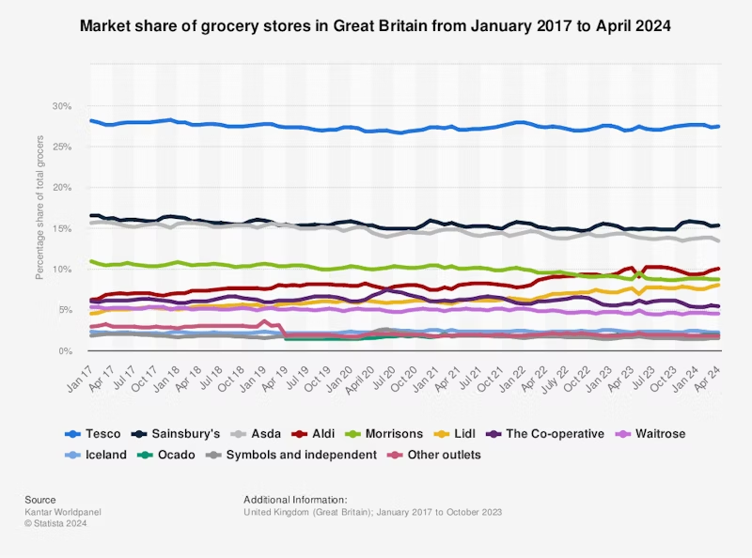

Lessons for Economics Students
From an economics perspective, Aldi’s recent performance underscores several key concepts:
Income Elasticity of Demand: The shift towards premium products as incomes rise illustrates how demand for different goods can vary with changes in consumer wealth or confidence.
Market Dynamics and Competitive Strategy: Aldi’s situation highlights the importance of adapting to competitive pressures and evolving market conditions. The supermarket's need to differentiate itself beyond price underscores the strategic challenges businesses face in mature markets.
Investment and Growth Strategies: Aldi’s expansion plans reflect a classic business growth strategy, leveraging capital investments to drive future sales. However, as Aldi approaches its store limit, it will need to explore new avenues for growth, potentially including innovation in product offerings or services.
Consumer Behaviour and Economic Recovery: The changing shopping habits at Aldi, where consumers are choosing to 'celebrate at home' rather than dine out, reflect broader economic and social trends. This behaviour can influence demand for certain products, thereby affecting overall market dynamics.

Questions:
- What does the shift towards premium own-label products at Aldi suggest about income elasticity of demand?

- How has Aldi's competitive position changed in the UK grocery market recently, and what strategies are its competitors using?

- What are some of the challenges Aldi faces as it continues to expand its store network?

- How might economic recovery influence consumer behavior in the grocery market?

- Why is differentiation important for Aldi as it seeks to maintain its market position?

Task 3
Read the following article from the BBC and answer the questions below:
https://www.bbc.co.uk/news/articles/c17rgd8e9gjo

Questions:
- Explain what is meant by inflation.
- Explain why inflation in the UK soared. What were the consequences on households?
- What is the current rate of interest? (base rate).
- Why do you think they manipulate the rate of interest in help control the rate of inflation?
- Explain what has happened to the rate of wages growth from 2015 – 2025.

Task 4: The Bank of England
https://www.bankofengland.co.uk/education/home-learning-hub/post-16-economics-learning-resources

Research the role of the Bank of England, interest rates and monetary policy. Produce a one-page fact sheet.

Task 5: Economics Vocabulary
Create revision cards for: GDP, inflation, unemployment, recession, productivity, taxation, imports, exports, exchange rates, interest rates, fiscal policy, monetary policy, opportunity cost, scarcity, demand and supply.

Task 6 : Recommended Reading
Read at least TWO articles and summarise each.
Suggested articles:
• Bank of England – Inflation explained: https://www.bankofengland.co.uk/knowledgebank/what-is-inflation
• BBC Bitesize Economics: https://www.bbc.co.uk/bitesize/subjects/zrwhfg8
• ONS Economy Hub: https://www.ons.gov.uk/economy
• IMF – Back to Basics: https://www.imf.org/en/Publications/fandd

Task 7: Economic Indicators/data UK
Research and write the correct figures in the table below for 2026.
UK GDP Growth
Per Capita GDP UK
UK Base Rate
UK Inflation Rate
UK unemployment Rate
UK unemployment
UK BOP (Current Accoun)
UK Export Value
UK import Value
UK Gini Coefficien

Also, write a short paragraph on each of the above concepts.
GDP Growth
Per Capita GDP
Base Rate
Inflation Rate
Unemployment Rate
Unemployment
BOP (Current Accoun)
Export Value
import Value
Gini Coefficien

Task 7: Reflection
1. What was the most interesting thing you learnt?
2. Which task challenged you the most?
3. Which economic issue will you continue to follow?
4. What are you looking forward to studying in Year 11?

