BTEC Level 3 National Diploma in Business

Unit 2: Course Booklet.

Developing a Marketing Campaign
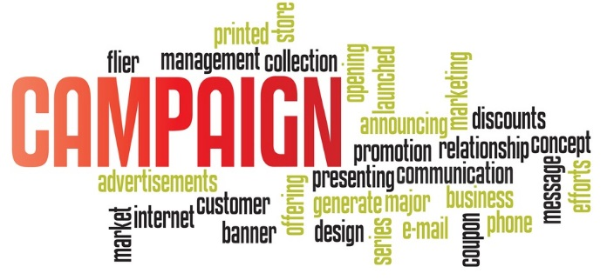

You must have this booklet with you at all times in class, and it should be kept in your business folder.
Name: ……………………………………………………..

Week 8
Learning Aim A: - Introduction to the principles and purposes of marketing that underpin the creation of a rationale for a marketing campaign.

A1- The role of marketing
Activity 1-
In pairs decide upon a definition of marketing.

Activity 2-

List the ways that businesses can identify the needs of their customers….

Activity 3-

What can be factors that affect the prices in business?
https://www.youtube.com/watch?v=RtUKuO0cSoQ

Activity 4-
In your paired group list all of the methods that could be used to promote a brand.

Activity 5-
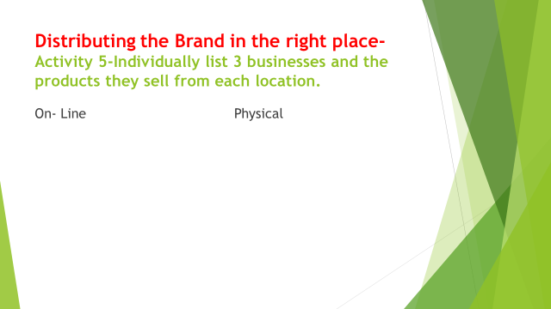

Activity 6-

- What does an ice cream manufacturer have to do to anticipate demands on sales?

- How does a department store prepare for Christmas sales of the latest toy craze generated by Star Wars or Frozen?

3. Who in the business does this?

Activity 7-
In small groups collectively come up with a SMART business objective.
- Write on a post it and stick on wall!

Activity 8-
Following on from your business objectives, collectively as a group come up with 2 marketing objectives that will help to achieve your business objective.

Activity 9-
- Discuss in your groups how you can do this in a business, come up with 4 ideas from your previous business.

Activity 10-
Research in your groups the current market share for the following businesses.
Tesco
Lidl
Pedigree Pet Food
Mondelez – (Cadburys)
Ford-

Over to you!!!
In pairs you are to research 4 organisations:
- A for profit( private ) organisation
- A social enterprise
- A public sector organisation
- A charity or trust
For each you are to find out
- Their mission
- Their corporate/ business objectives
- Their marketing objectives.
Then present your findings to your tutor in the form of a word document.

Week 9
- Learning Aim A: - Introduction to the principles and purposes of marketing that underpin the creation of a rationale for a marketing campaign.
- A1- The role of marketing

Connect Activity –
- Write down what is meant by market share and provide an example.

Activity 1-
Individually research what is ‘market segmentation’ and write your answer on a post it note.

Activity 2-

Learners to watch film and complete built in activity from film.
http://www.youtube.com/watch?v=llJNwdV-G88

Activity 3-
In groups list as many reasons to why Market Segmentation is important?

Activity 4-

Research what is the difference between a mass retailer and a niche retailer and provide an example?

Over to you!!!

- Learners all to explore a specific market of their choice such as the phone/fashion market and then individually write a report on how the businesses in that specific sector segment the market and in what way, provide research, examples and referencing material in your work.

Week 10
- Learning Aim A: - Introduction to the principles and purposes of marketing that underpin the creation of a rationale for a marketing campaign.
- A1- The role of marketing

Connect Activity –

- As a recap from last week write down one reason to why segmentation is important.

Activity 1-

Individually come up with a definition of what branding means, write answers on your work book?

Activity 2-
Watch the film and the learners are to watch the film and answer questions on the film from the sheet provided by the tutor.

https://www.youtube.com/watch?v=JksgYvYmVEw

Activity 3-
Think of a business that offers a product/ service that has a USP and write the product/ service example and its USP….

Activity 4-
- Individually through the internet find an example of a business that has developed a range of products to cater for different faiths and beliefs

Activity 5-

List all of the potentials roles that marketers offer. (What can they do to help businesses?)

Over to you!!
Individually you are research two brands. You are to:
- How the brand image is identified and show examples.
- Who is the targeted customer segment, provide details.
- How the needs and wants of the customer that are satisfied by the brand.
Present your work in the form of a word document.

Week 11
- Learning Aim A: - Introduction to the principles and purposes of marketing that underpin the creation of a rationale for a marketing campaign.
- A1- The role of marketing
Connect Activity
- Write down one Mass retailer and one Niche Retailer on a post it.

Activity 1- Cost of the Campaign
- Where else?

Activity 2-
Now research what you think advertising agencies do?

Activity 3-

- List the methods of advertising that have been created by this company Leo Burnett and for which businesses?

Activity 4-

Each member of the table is to help research the meaning of PESTLE.

- What does each letter stands for?

- Give an example of what it means in business terms.

Over to you!!
- For the rest of the session you are to look at a campaign and explore how the campaign was influenced by each element of the PESTLE model.
- Formulate your work into a word document for future reference.

Week 12/13

Case Study
The ice cream market
On average, each person in the UK eats nine litres of ice cream every year. This is just a quarter of what they eat in New Zealand, the world leaders, and less than almost every country in Europe. Even Finland, not known for its balmy summers, sells double this amount of ice cream.
Of the people in the UK who buy ice cream, 49% buy tubs, while ice cream sticks are bought by 51%, 35% love a cone, 31% buy lollies and 25% of people buy ice cream from vans. The UKs ice cream market has grown by 20% in the past five years, and is now worth £1.1bn.
While many people are only aware of a handful of ice cream makers there are over 1000 in the UK producing a wide variety of flavours. Specialist ice cream outlets and shops are fast becoming a niche market and appearing in many places across the UK. Diversification into the ice cream market The following information relates to Rebecca’s Dairy, a farm planning to diversify into the making of artisan ice cream.
Rebecca’s Dairy Rebecca’s Dairy is a working organic dairy farm that was started over 60 years ago in Cornwall. The dairy herd has continued to grow and the business currently produces about 450,000 litres of organic milk annually.
However, since last year, the business has been facing financial difficulties from falling milk prices, overproduction and increased competition together with the requirements of large milk buyers such as supermarkets and their impact on milk prices. Because of its financial difficulties, the business is looking to diversify and is considering additionally producing and selling organic artisan ice cream, as this end of the market is the fastest growth area for ice cream.
Rebecca’s initial plan is to use around 20% of current milk production for ice cream, moving to a higher percentage if the new product is successful. The business already has the physical and human resource capacity to switch production from milk to the new products and aims to market a limited range of natural flavours in the first instance.

The initial marketing budget for ice cream is set at £50 000 and there is scope to increase this if the campaign proves successful. A neighbouring non-organic dairy farm is also considering diversifying into ice cream production.
It currently produces in excess of 1 million litres of milk per year. If it decides to do this there may be an impact on Rebecca’s plans.
What is artisan ice cream? Quite simply, artisan ice cream is ice cream made by an artisan; a skilled craftsperson. It also uses processes and machinery that need the ‘human touch’. This may be choosing and mixing the ingredients or keeping a close eye on the freezing to make sure the ice cream is of the smoothest, highest quality possible. Artisan ice cream is not mass produced, it is a luxury product. How is artisan ice cream made? As well as the experience and skill of the artisan, great ice cream begins with great ingredients that include fresh whole milk, eggs, butter and cream that are blended together and whisked to make that light melt-in-the-mouth texture.

Activity

Prepare a rationale for Rebecca’s artisan ice cream marketing campaign.
This should include:
- Putting together marketing aims and objectives
- research data on the market and competition
- How should she spend the marketing budget
- What should she diversify into?
- Provide justification for your rational to include research and references.

Week 14
Learning Aim B: - Using information to develop the rationale for a marketing campaign

B1- Purpose of researching information to identify the needs and wants of customers.

Starter Activity
Individually on phones research the meaning of Market Intelligence. (Write on a post it)

- Activity 1- Individually on phones research the meaning of Market Research.

- Activity 2- In pairs write down as many research methods that you can think of that are used in the marketing sector.

- Activity 3- As a group you are randomly select two from the envelope and discuss how each method is put into practice and provide a specific example of how it would work in the marketing industry.

- Activity 4- Research what is meant by Demographics…..

Activity 5- research then describe the difference in qualitative and quantitative research.

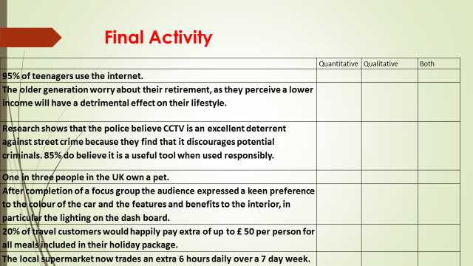

Over to you!
For the rest of the session, you are both to watch the film below then:
https://www.youtube.com/watch?v=gG-TeBQVo74
- Describe the difference in qualitative and quantitative research.
- For each of the marketing research methods discussed in the session you are to discuss which methods are better for collecting quantitative data and which qualitative data.
- Give concrete examples of each data for each method.
- You are to conduct research for a Pizza restaurant.
- You are to investigate and research the needs and wants of the consumer.
- Advise on the research methods the organisation could use to develop their business further.
- Also identify their competition, what types of marketing methods does the competition use?

Week 15
Learning Aim B: - Using information to develop the rationale for a marketing campaign

B2- Market research methods and use.

- Connect Activity –List on a post -it as many methods of marketing research methods a business could use then stick post-its on the wall….

Activity 1-
There are two types of research:
- Primary
- Secondary
Activity 1 What is the difference?

Activity 2-
List as many Primary research methods that can be used then stipulate whether it is an internal or external method

Activity 3-
- List as many Secondary research methods that can be used, internal and external.

Activity 4-
- When launching a new product/ service how would you determine who your target market is?

Final Activity 5
How can you find out what your competitor's do?

Over to you!!!
Case Study
- Your next stage in your academic progression is to go to university to study Business .
- However you are unsure of which course to choose and where to study it.
- Your task is to collect as much research out through different methods, consider Primary, Secondary, Internal and External sources.
- Lastly consider size, structure and trends that may have a bearing on where you collate your research from.
- You are then to save your findings in a word document.

Week 16- Self Directed
Learning Aim B: - Using information to develop the rationale for a marketing campaign.

B2- Market research methods and use.
Activity 1
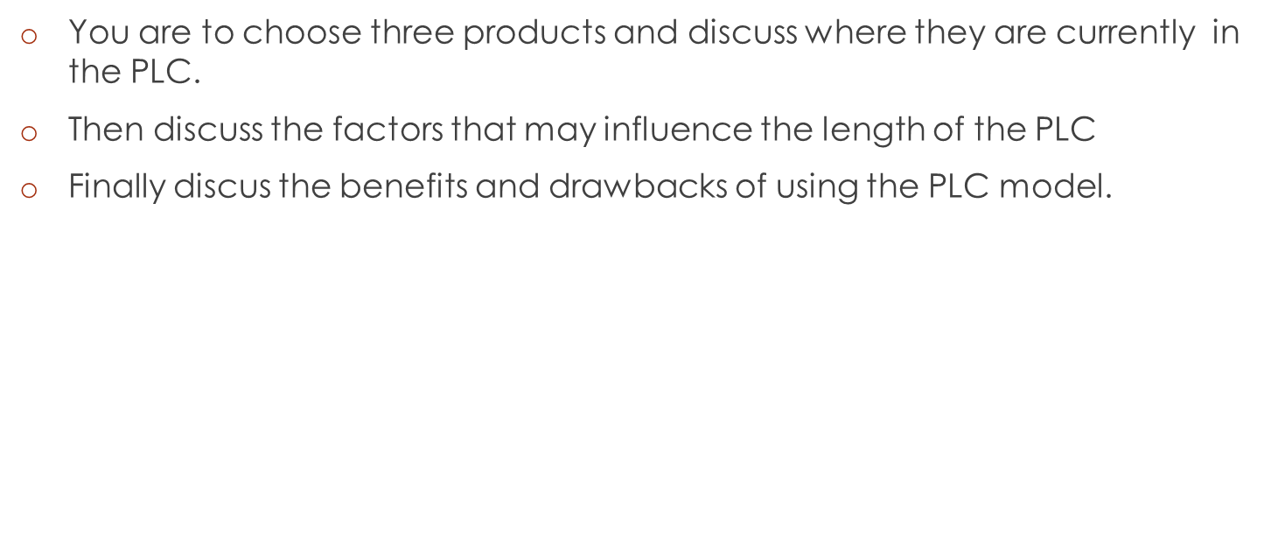
Activity 2
When watching the film you are to do a SWOT analysis on McDonalds.
https://www.youtube.com/watch?v=qbyb0ht-dsk

Over to you!!
- After you have compiled your 20-25 questions you are to conduct your survey with a mix of students within the college.
- Collect your results then evaluate the results. Record into a word document.

Evaluation
- Analyse each question or section and look at the majority answers.
- Was the correct amount of students asked?
- Did they all respond to all questions asked and give specific answers?
- Did they all answer the questions fully?
- Was your questionnaire compile and planned well initially?
- Would you add in or take out any questions?
- Has anything skewed your results?
- What the information does not tell you
- Could you identifying improvements.
- SWOT of your questionnaire results

Week 17-
Learning Aim B: - Using information to develop the rationale for a marketing campaign.

B2- Market research methods and use.

Connect Activity –

- Activity 1- In groups make a list of measures that a business could take to ensure the research they undertake is successful.

Activity 2-Come up with a list of valid sources of data that could be sourced by a business.

Activity 3- List all of the research methods that Chesterfield College uses.

Activity 4-
https://www.youtube.com/watch?v=86VezG85tyM
Answer the following:
- What are the 3 main constraints?
- What is the fastest and cheapest way to gather research?
- What problems does this give?
- Which method is the most expensive but offers good results?
- Why is mystery shopping criticised?

Over to you!!!
You are to create a questionnaire that uses qualitative and quantitative data .
- Your survey is to be on a student related topic (tutor approval needed).
- You need to identify a target market.
- It must be carried out in the college.
- It must include between 20-25 questions.
- Remember to ask the right questions and be specific and appropriate!
- Collect your results then evaluate the results.

Week 18-
Revision Quiz test

Week 19-
Learning Aim C- Planning and developing a marketing campaign
C2- Marketing mix

Connect activity

- Write down the meaning of SWOT and PESTLE

Activity 1

- Write down what you think the function of packaging is?

Activity 2
In pairs/small groups
- Match the type of packaging with the promotional message

Activity 3

- Individually you are to research the meanings of two of the four price strategies and provide an example.

Activity 4- Guerrilla marketing

- This is usually low cost, creative unconventional methods of marketing used to maximise sales return.
- Tactics such as:
Research and find one for yourselves!

Week 20-
Learning Aim C- Planning and developing a marketing campaign
C2- Marketing mix

Connect Activity

Activity 1
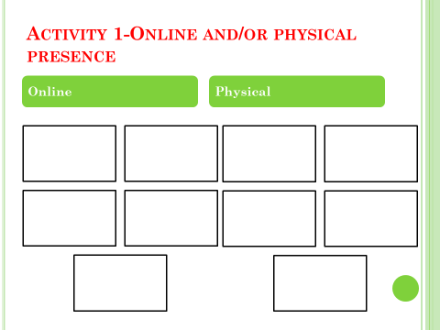
Activity 2

Technology allows organisations to ‘streamline’ many processes to improve the buying experience of the customer
-List the processes that help a customer order on line.

Activity 3
Individually answer the following questions:
- Why are people important especially in service industry?

- Why is training and development important?

- Why are uniforms, colours and logos important?

Over to you!!
Learners are to complete a poster for a business that uses the marketing mix.

Week 21-
Learning Aim C- Planning and developing a marketing campaign
C3- The Marketing Campaign

Connect activity- The Marketing Campaign- self directed

Activity 1-
- https://www.brandwatch.com/blog/best-marketing-campaigns-2016/
- Choose 4 campaigns from the top ten!!!!
- Which campaigns are creative?
- Which campaigns would generate new leads?
- Do the campaigns aim to inform or persuade?
- Are the campaigns simple or complex?
- Discuss what each campaign aims to achieve (e.g. brand awareness, lead generation or conversion, loyalty or upselling).
- Decide whether the message is clear or cluttered.
- Is the campaign is creative and/or memorable?

Activity 2
Learners are to examine the integrated marketing mix for a supplier of turf and how they would plan their campaign using all of the marketing mix.

Product
Pricing
Promotion
Place
People
Physical Environment
Processes
Packaging

Activity 3

- The budget is set to prevent overspending.
- Budgets must be agreed in advance and monitored closely.
- Calculations need to be based on the potential return for the investment.
List the ways that a business could set a campaign budget.

Activity 4
Learners are to research the individual costs of a campaign using the internet and other sources of information.

Activity 5

- You are to investigate the length of time required for creative design and the implementation of a successful marketing campaign.
- You are then to then create an appropriate time line, giving dates, with time also allocated for monitoring and assessing the effectiveness of the campaign.
Case study
- A new internet café on Saltergate, Chesterfield is to open with an "Italian coffee" theme. The owner wants business people to use the internet café for their breakfast as well as lunch.
- The timescale for the campaign will run over two months. (Saturday 2nd June 18-Saturday 28th July 18 which is the day of opening.
- The available budget is £5,000.
- Select the right form of media for your target market and use appropriates methods.
- Break your budget down and show how you will spend the money and how you will plan your time to evaluate progress.

Week 22-
Learning Aim C- Planning and developing a marketing campaign
C4- Appropriateness of Marketing Campaign

Activity 1

As a recap from last week list the sorts of questions you might ask yourself after your campaign on the Italian Internet cafe to evaluate its performance and success.
- Was the main campaign message clear?

- Was the brand made clear?

- Was the campaign well executed?

- Was the correct target market chosen?

- Has the campaign re-enforced the aim of the business?

- Was the appropriate advertising methods used?

- Did we spend the money wisely?

Activity 2

Examine the Cadburys campaign for the White Chocolate Egg and provide for each part of PESTLE an example of internal or external factors they have or may have to consider and react to.
- P-
- E-
- S-
- T-
- L-
- E-
Activity 3
Learners are to find examples of a campaign for each of the categories of market listed below that have used the most appropriate method of advertising and appropriate message:

- Children aged 5-10

- Young females aged 16-25

- Young males aged 16-25

- Older females aged 35-50

- Older males aged 35-50

- Senior females aged 60-80

- Senior males aged 60-80

Find a campaign image for each, copy and paste and label according to target market category.

Over to You!!

Choose a marketing campaign then evaluate whether this campaign is appropriate or not.

Answer all of the questions on the task.

