Unit 1:
Exploring Business


Learning Aim, A:
Explore the Features of Different Businesses & Analyse What Makes Them Successful

Name: __________________


Task
Consumers rely on businesses every day. Make a list of businesses, starting with any you have used this week. How many sell products? Which provide services?

Partnerships

Economy

Liability

FTSE

Most businesses rely on __________ ____ ________ and the bigger the profit, the more ________________ ______ _____________.
Although, not every business measures its success by the amount of profit it makes.
However, the way a business is organised to ___________ _____ _______and _______ _____ ______ ____ ____ ___________ is critical to its success.
Features of Businesses
- Another word for ‘___________’ is ‘_______________’ or ‘__________’; therefore, business features comprises the characteristics that make up every organisation.
- For example, sole traders, such as a plumber or mobile hairdresser offering a service to customers _____ ______ ____________.
- Other businesses might be very big and sell their products or services __________ ______ ____________, such as the BBC and Virgin Atlantic.
Ownership and Liability
Businesses are owned in one of three ways:

Private
- __________ ____________ are those owned by ___________ and therefore they are liable for all aspects of the business.
- Owners of private businesses are likely to ________ ________ _____ as they are in business to make a profit.
- _________ ________ businesses can be of ____ _______ and owned by many partners. Some of the largest include:
- Virgin
- Mars
- Tesco
Public
- _________ _____________ which are identified as belonging to the public section are owned by the ________________ or subsequently bought by the government from the private sector for investment or to save them from financial ruin, such as Northern Rock and the Royal Bank of Scotland.
- As the government is then liable for the success or failure of the business, they are ____ __________ ___ ______ ________ than businesses in the private sector because they aim to _________ _____ ________.
Not-for-Profit
- Businesses which do not aim to make a profit are often _____________ ______________.
- Businesses often share many of the same features as private and public businesses, such as running on normal business lines, and have many paid workers but only seek to _______ _________ __________ ____ __________ ___________ _________.
- _____________ ______________ are also not-for-profit businesses. They are set up, organised and staffed by people working on a purely voluntary basis.

Private, for example: |  | Public, for example: |  | Not-for-profit, for example:
Sole trader |  | Government department |  | Charitable trust
Partnership |  |  |  | Voluntary
Private limited company
Public limited company
Cooperative

Privately Owned Businesses
____________ _________ businesses can decide to become limited companies at any time. A decision to do so might be made to ensure that business profits and liabilities are properly shared based on the percentage of ownership by each of its directors. Business ____________ _____ _______ __________ ______ ___________ ___________, therefore, if the business fails, owner’s personal assets, such as homes, cars, etc, ____________ ___ ______ ____ _____ _____ _____ ______.
Owners of Limited Companies
Owners of ___________ _____________ have to pay corporation tax and can draw __________ from their business. Depending on personal tax liabilities, it may be beneficial to change the business structure to a limited company.
Some owners find they can increase their business opportunities by becoming a limited company as it may give the impression that they are larger or more established than they are. Some large organisations will only contract with limited companies
Partnerships
A partnership is a business where there are two or more owners of the enterprise. Most partnerships are _____________ ______ ______ ___________ ___________though there are examples like John Lewis and some of the major world accountancy firms where there are hundreds of partners.
Liability
To protect the business against the risk of being sued or held legally responsible, anyone owning or running a business should insure against such ___________.
Depending on the ______________, ________ and _______ ____ __________,the cover will also vary.
Unlimited Liability
Some businesses are owned by sole traders or partnerships. If the owners share the business responsibilities ____________, they are responsible not just for the __________ but also the ____________, such as debts and claims against the business. This could mean all savings and possessions including car, house, etc are at risk.
Limited Liability
This means there is a __________ (or cap) placed upon the amount that can be claimed.
This means the owners capital and possessions are _____ _____ _______.
Purposes
Most businesses ___________ __________ ____ _________, or occasionally ________. For example, some businesses, such as dentist, provide a service and also sell a small range of products such as toothpaste, floss, toothbrushes, etc. Halfords provide products such as car and bicycle parts and they also provide a service whereby they fit windscreen wipers or bicycle tyres.
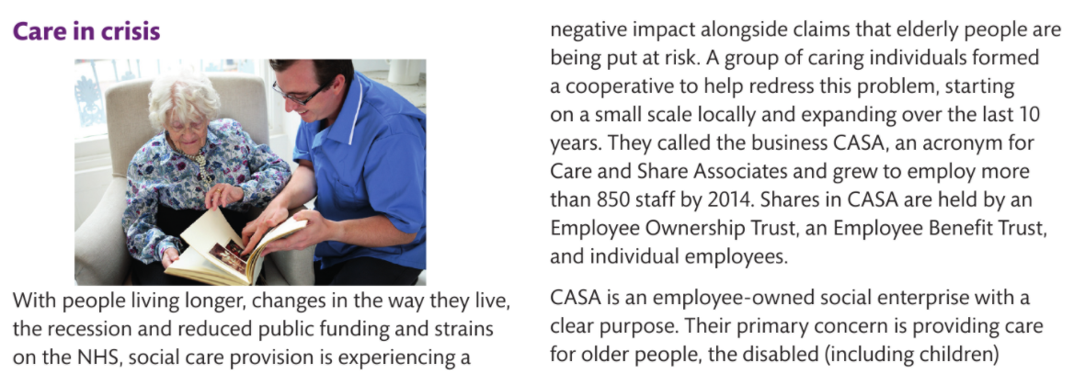
Pause Point- Case Study- Care in Crisis
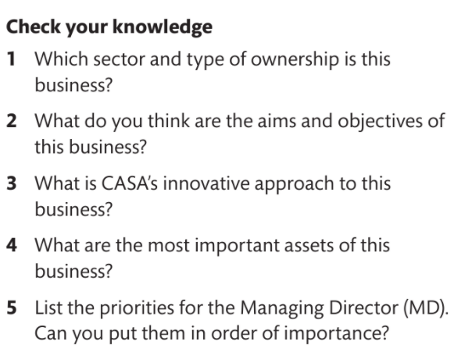
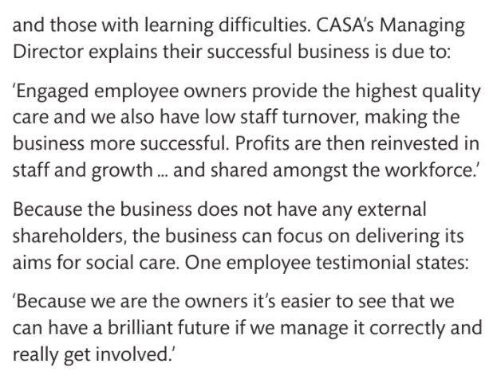

Pause Point
Why is profit not the most important goal for this business?
Hint- without referring to the case study, list all the reasons that profit is not the main aim.
Extend- what non-financial rewards do employees receive from their involvement with this business?

Task
What is the difference between unlimited and limited liability?

Research
For your assignment you need to research two contrasting organisations. Research which business you would like to research and show your teacher.

Task
Ownerships | Definition | Liability | Advantage | Disadvantage
Sole trader
Partnership
Private Limited Company
Public Limited Company
Cooperative

Sectors
Businesses operate in different sectors according to the nature of their business and the product or service they provide. These sectors are known as ____________, ___________, ___________ and _____________ and are the four stages of the journey from sourcing a material to being ready for the customer.

Primary Sector | Secondary Sector | Tertiary Sector | Quaternary Sector
Let’s take an example of a customer such as a builder who requires the roof trusses for a house – the builder relies on the primary sector to source the raw materials and on the secondary sector to prepare those materials from their raw state so that they can form the frame for a roof | The secondary sector processes the raw materials produced by the primary sector so that they can be sold on. For example, farmed vegetables, mined diamonds or coal, felled wood and caught fish, all need to be prepared or manufactured in some way by the secondary sector so that they are fit for sale. | This sector provides the supporting services which store and distribute the goods which have been manufactured. Businesses often rely on advertising to promote their products- another service provided by the tertiary sector. The tertiary sector also sells skills support such as training for staff. Types of tertiary business include services such as travel and tourism, entertainment, education and training, and transport. | Together with the tertiary sector, employees working in the quaternary sector currently account for 75% of the UK workforce. This sector also provides support services and can appear to overlap the tertiary sector. Examples include the communications infrastructure for day to day operations, such as telephoning and emailing.  Therefore, this fourth (quaternary) sector relies on information from other sectors to test existing products and methods, and to develop new ways of sourcing and producing new products or approaches.

Scope of Business Activities
Local
The scope of a business means the ___________ _____________ by that business. A local business is usually one which is owned locally and ____________ _________ _____ _______ __________, such as an independent village shop or perhaps a pub which is owned by local residents. There are, of course, exceptions. Some local businesses, such as your local council office, are part of a much bigger organisation although they provide a service to the local area.

National
Some franchised businesses in your area, for example Harvey’s Furniture Store, Kwik Fit and McDonalds.
The government defines a ___________ as ‘the owner of an established business format (the ____________) grants to another person (the _____________) the right to distribute products or perform services using that system’ and a fee is paid to the franchiser according to the terms of their agreement.
International
International business does business transactions that take place across national borders. Since the birth of the internet, international business has provided with _______________ ____________ to sell products and services.
Measuring the Size of a Business
To accurately quantify the size of a business, strict definitions exist and these are outlined below
Size Type | Number of employees/staff
Micro
Small
Medium
The above are all known as SMEs (Small and Medium Enterprises)
Large
Reasons for Success
There are different reasons for success depending on the type of business (profit or non-profit) and its aims and objectives, which you will explore shortly.
Profit Seeking Business
Businesses seeking to make a profit are motivated by various reasons. For example;
  - To pay the bills for _____________ ___________,
  - Have money for extras and realise some ___________ such as owning your own home, buying a nice car, having holidays, etc.
As businesses get larger they generate ________ ____________. For example;
  - Might employ additional staff,
  - Pay for premises
  - Develop products or services to expand on its market share.
Profit Seeking Business
- Just because a business grows it does not automatically follow that it becomes more ______________. This is because its costs might increase and the ___________ ________ paid on loans or investments could fluctuate.
- Sometimes businesses call on the services of other sectors, for example for ____________ _________ _________from a consultancy service (perhaps on running the business more efficiently to make more profit and reduce costs).
Non-Profit Seeking Business
The primary goal of these businesses is not to make substantial profits but enough to _________ ____ _________. Therefore, they also need to keep a very close eye on their finances to ensure that what they spend does _____ _______ ____ __________ _______ ________, known as revenue
Revenue is not necessarily gained from selling a product or service but could come from successful bids for __________ or __________, _____________ from members of the public or perhaps lottery funding.
Aims and Objectives
Every business need aims and objectives, every business must have a purpose and outcome.

Clarity of Vision
Plans can change due to influences of the market forces, for example ______________ _________.
___________ ____________ help a business to focus on its ___________ and how it can continue to operate.
Innovative Products or Processes
______________ _______________, or creative ways to go about a process, can lead to business success.
What makes good business sense is to be creative- employers are always looking for employees who can __________ _____ ___________ and propose more ___________ _______ to manage a process or ___________ innovative products or services.
Research
For the two businesses you have selected (contrasting businesses) research the following;
- What is their ownership and liability?
- What are the business purposes?
- What sector are they in?
- What size is the business?

Task
Write an example of a business that uses the different sectors
Primary Sector | Secondary Sector | Tertiary Sector | Quaternary Sector

Task
Stakeholder feedback

Regulator

Shareholder value

Customer retention

Stakeholders
There are two types of stakeholders, internal and external. In other words, those within the business, such as its employees and those outside the business, including customers and anyone else with an interest in the business. They all have a stake in the business.
Stakeholder | Influence
Internal Stakeholders
Managers/employees: | Work for the organisation. Managers manage performance of employees. Seek job security, promotion opportunities and fair pay.  Have a lot of influence and make the business change their aims and objectives to include staff needs and wants, for example working conditions. If there is high unemployment, employers are in a more powerful position as employment is harder to find.
Owners
External Influences
Suppliers
Lenders
Competitors
Debtors
Creditors
Customers
Government agencies and departments
Communities
Pressure groups and interest groups
Shareholders

Pause Point- Case Study
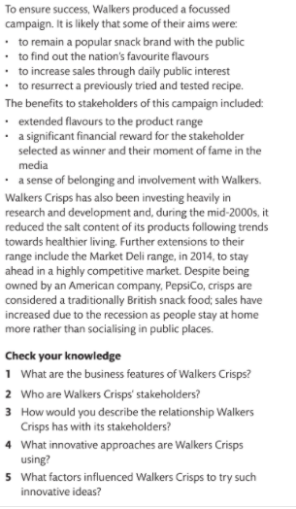
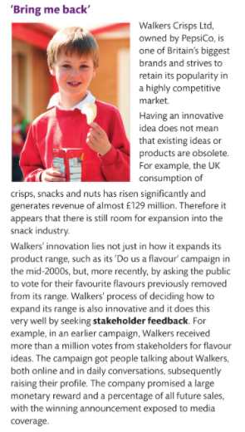

Corporate Social Responsibility
Often shortened to CSR, corporate social responsibility means the contribution that a business has committed to make to ___________ and the ______________. To deliver such a commitment, employees are encouraged to volunteer in a community project and work with community groups. The business might allocate the equivalent of one day a year to such an activity. Several major businesses are known for this strategy.
Research
For the two businesses you have selected (contrasting businesses) research the following;
- Who are their stakeholders?
- What influence does the stakeholders have on both business?

Task
Which stakeholder do you believe has the biggest influence?

Pause Point- Little Italy- Case Study
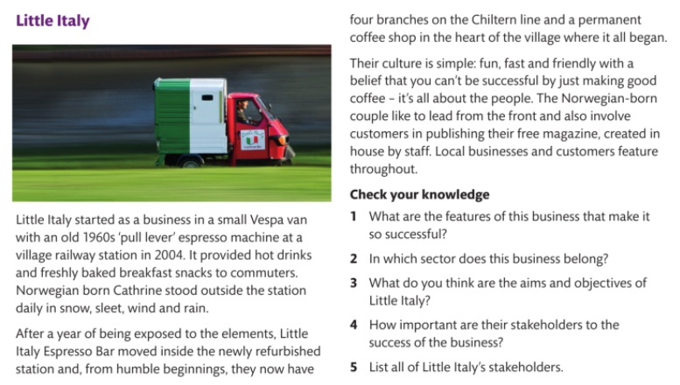

Effective Business Communication
Without effective business communications, a business is ____________ _____ __________.
While English is widely spoken around the global, it is too easy to assume that everyone understands exactly __________ _____ ___________.
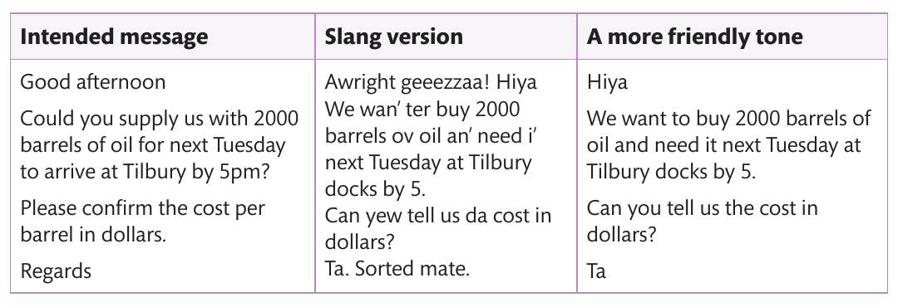

Written Presentations
In business, presentations take place almost continually. __________ can be ________, for example those which deal with business matters relating to finance or policy, such as government reports. A finance department (which may comprise just one or two people in a SME) will routinely produce a set of written monthly accounts as a formal report.
While electronic software is probably used to produce the financial accounts and the report, an _____________ of what the figures actually mean will be more appropriate than providing lots of _______ or _______________ __________. This means that the accounts need to be explained in a different format so that others can understand them clearly. This could be informal, for example by using a flip chart, or talking others through the information. Informal reports can also describe progress on a ___________ _____ ________. In this case, the language will reflect a less formal and less business-like approach.
With all written presentations it is important that the information provided is ______________ and presented in an appropriate format.
Example of ways to communicate in business
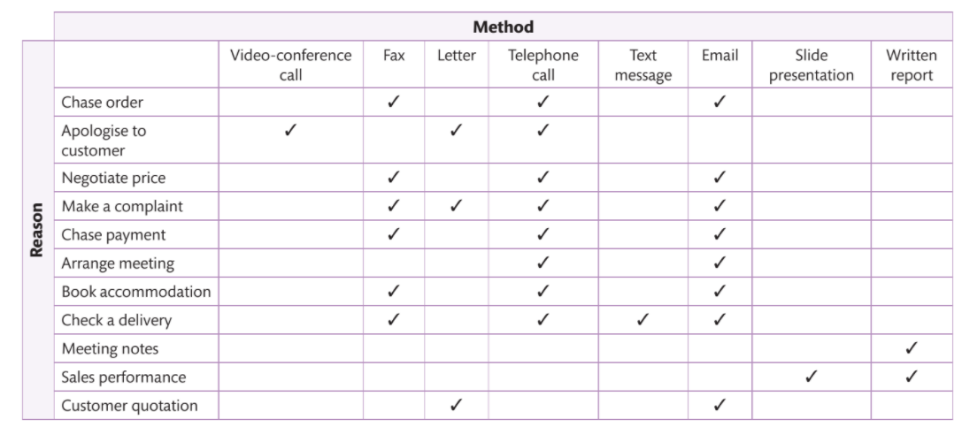
___________ _______________ may be used to present some reports, especially where employees are unable to attend one site or always work cross-site. _________ are used infrequently these days but do still exist, especially overseas or in remote locations where internet connection is less reliable
Oral Presentation
________________ are often accompanied by a speaker, where professional presenting software is used. This is because each slide should only provide a headline account, with the detail explained by the presenter. Presentations are especially useful when communicating to ____________ _________________ or when giving a series of presentations. They may be accompanied by ___________ _____________.
It is important to consider the purpose of communicating and whether the language used needs to be adapted to different audiences. For example, ___________ _____________ is understood by a _______________, such as mechanical engineer or IT technician, but it needs to be adapted if you are proposing changes to a network system to non-expert users of that system.
Importance of Communication to Aid Business Success
Social media can be a great way of ____________ ___ _______ ______________ and getting it known across a wider community (like Little Italy promoting its services to customers through its website and newsletter). Regardless of business size, social media is being used more widely each year and those dominating business communications include LinkedIn, Instagram, Facebook and Twitter. Government offices also rely on social media. Although there are reservations about using social media, it can recap rewards if it used responsibly.
Social networks which develop through the use of _______ ____________ become virtual communities, spanning diverse geographic locations and ignoring political boundaries. Less obvious examples of virtual communities include those initiated by inventor James Dyson and Brompton Bikes.
These virtual communities can thrive on common interests and develop fresh _________, extend ____________ and be useful for business owners who are considering ways to expand or even start up a business. Virtual communities can make or break a business and _______ ______ _________ ___________. Sites as TripAdvisor use virtual communities for gathering reviews from customers on their experiences.
Some businesses, such as Microsoft, use discussion boards to generate ongoing interaction whether to promote a product or service, or to report or solve problems. Sites such as Educator Network evolved to bring tutors together across the globe to share their ___________ and _______________ ________ and ____________. They have helped to provide innovative ways to teach ‘hard to learn’ topics and better understand _______________ ______________.
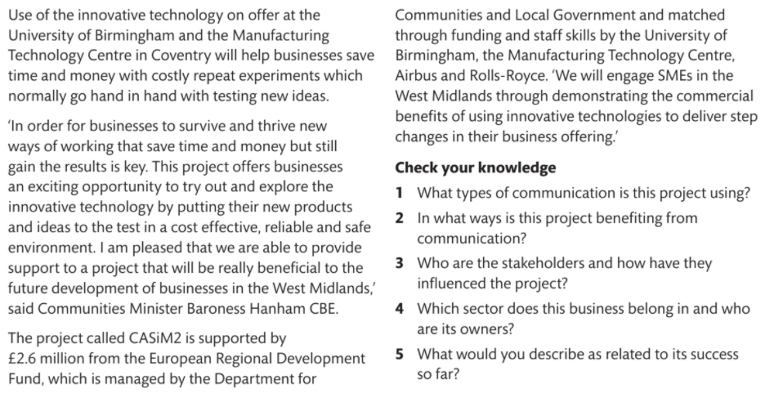
Pause Point- Case Study
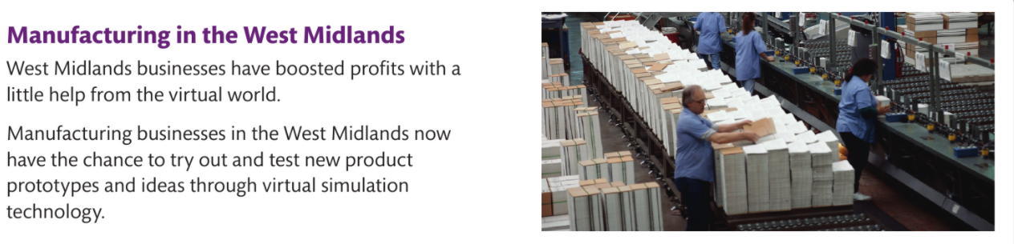

End of Unit Summary



