Introduction to A-Level AQA Sociology Transition Task

Welcome to AQA A Level Sociology at BSF!
To help you make a strong start in September, you are required to complete the following preparation tasks over the summer holiday. These activities will introduce you to some of the key ideas and concepts that we will study throughout the course.
You must bring your completed work to your first Sociology lesson in September.

Task 1: Purchase the Y12 Course Textbook
Please purchase the AQA A Level Sociology Book 1 textbook:
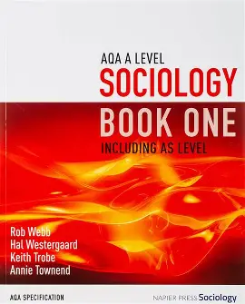
https://amzn.eu/d/02di3aO4 (textbook on Amazon)
You may choose to buy the textbook new or used, and you are encouraged to compare prices from different retailers to find the best option for you. The textbook will be used regularly in lessons and for independent study, so you will be expected to bring it to every Sociology lesson.
If purchasing the textbook would cause financial difficulty, please contact Ms Param (Head of Social Sciences) as soon as possible so that support can be arranged.

Task 2: Introduction to Key Sociological Concepts
Research the following sociological concepts and create a mind map (or a series of mind maps) that briefly explains each one (Please see the example mind map below for guidance).
Topics to Research
- What is Sociology?
- What is the Nature vs Nurture debate?
- What are culture, norms and values?
- What is socialisation?
- What is the difference between structural and social action theories?
- Sociological perspectives: Functionalism, Marxism, Feminism and Postmodernism
Your mind maps should include a brief definition of each concept and any key ideas or features.
The Introduction to A-Level Sociology videos on YouTube by Tutor2u will help you complete this task and provide a useful introduction to some of the key concepts you will study during the course. You are welcome to use these videos as a starting point, but you should also make use of other reliable sources to support your research – the textbook will also help with this.
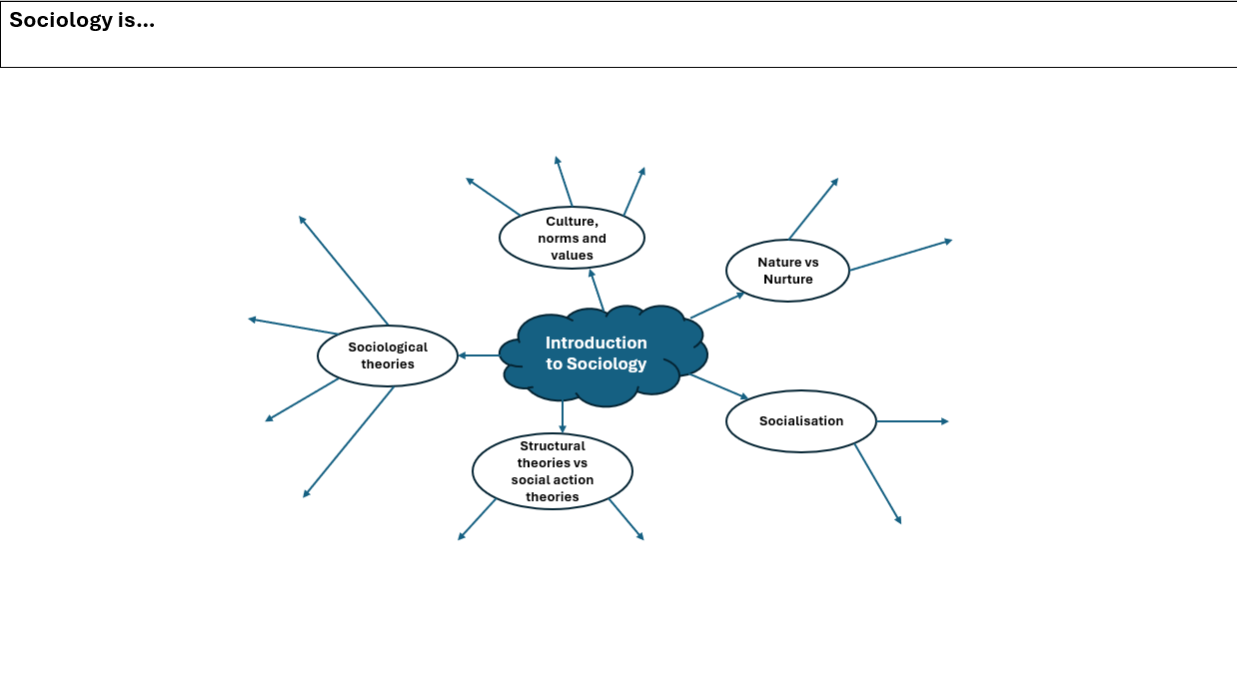
Example Mind map:

Baseline Assessment
During your first week in Year 12, you will complete a baseline Sociology assessment based on the content covered in this summer task. This assessment is designed to help your teachers understand your current level of sociological knowledge and identify areas where you may need additional support. Your work will be assessed, and you will receive one of the following outcomes:
- Strong Start – You have demonstrated a strong understanding of the key concepts and are well prepared to begin the course.
- Secure Understanding – You have a good understanding of the key concepts and are ready to begin the course.
- Developing Understanding – You have begun to develop your understanding of the key concepts but would benefit from further review and preparation.

Completing the summer task thoroughly will give you the best possible start to your A Level Sociology studies.
We look forward to welcoming you to the course in September!


Optional Sociological Movie Recommendations:
The Truman Show (PG) - Truman's entire life is controlled and observed without his knowledge. Think about how society shapes behaviour and how individuals conform to social expectations.

Freedom Writers (12) - A teacher works with a diverse group of students from disadvantaged backgrounds, highlighting how factors such as ethnicity, social class and life experiences can shape educational achievement and opportunities.

Hidden Figures (PG) - Based on a true story, the film follows three African American women working at NASA in the 1960s and explores how gender and racial discrimination created barriers to opportunity and success in society.

The Pursuit of Happyness (12) - Based on a true story, the film follows a struggling father as he attempts to overcome poverty, raising questions about social mobility and whether everyone has an equal chance of success.
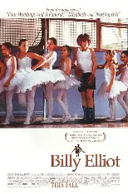
Billy Elliot (12A) - A young boy challenges traditional ideas about masculinity by pursuing ballet, highlighting how gender norms and social class can influence people's opportunities and choices.
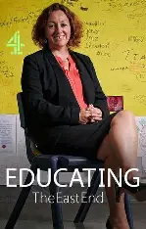

Educating The East End Series - The series explores life inside a modern secondary school and highlights the role schools play in socialising young people and maintaining social order.

