KS5 History Year 12 to year 13 transition work
In Year 13, you will study civil rights in the USA from the end of the Civil War in 1865 to 1992. This unit explores how different groups fought for equality and how successful they were in achieving their aims.
You will investigate:
- African Americans
- Trade Union and Labour Rights
- Women
- Native Americans
Exam Information
Unit Title: Y319: Civil Rights in the USA 1865–1992
Exam Length: 2 hours 30 minutes
A-Level Weighting: 40% of the full A-Level
Marks Available: 80 marks

Task one: Complete the pre-reading below and highlight key information

Introduction: What are Civil Rights?
Civil rights are the rights and freedoms that ensure individuals are treated equally and fairly by the law. These include the right to vote, equal access to education, equal opportunities in employment, freedom from discrimination, and protection under the law. Although the United States was founded on the principle that "all men are created equal," many groups were denied these rights for much of the nation's history.
The period from 1865 to 1992 saw significant struggles for equality among African Americans, women, Native Americans and workers. During this time, some groups achieved remarkable progress, while others continued to face discrimination and inequality. Throughout the course, students will investigate the extent to which these groups improved their position in American society and assess the role played by protest movements, the federal government, the Supreme Court and key individuals in bringing about change.

African Americans
The struggle for African American civil rights was one of the most significant and influential civil rights campaigns in United States history. Between 1865 and 1992, African Americans experienced both dramatic progress and severe setbacks in their quest for equality. Throughout the period, debates emerged over the role of the federal government, the effectiveness of protest movements, and the extent to which legal equality translated into genuine social and economic change.

The Civil War ended in 1865 with the defeat of the Confederacy and the abolition of slavery through the 13th Amendment. This marked a major turning point in African American history. During the Reconstruction period (1865–1877), the federal government attempted to rebuild the South and integrate four million formerly enslaved people into American society. The 14th Amendment granted citizenship to African Americans and guaranteed equal protection under the law, while the 15th Amendment gave African American men the right to vote.
For a brief period, Reconstruction appeared to offer genuine opportunities for African Americans. Black voters participated in elections across the South, while African Americans were elected to local, state and federal political offices. New schools, churches and businesses were established, helping to strengthen Black communities. However, progress was heavily dependent on the continued support of the federal government. Many white Southerners opposed Reconstruction and viewed racial equality as a threat to the traditional social order. Resistance to change emerged quickly. White supremacist groups such as the Ku Klux Klan used violence, intimidation and murder to discourage African Americans from voting and participating in politics. As northern commitment to Reconstruction weakened, federal protection declined. The Compromise of 1877 effectively ended Reconstruction by removing federal troops from the South. Historians often view this as a major turning point because it allowed southern states to reverse many of the gains made by African Americans.
Following Reconstruction, the South entered a period commonly known as the era of Jim Crow. State governments introduced segregation laws that separated African Americans and white Americans in schools, public transport, restaurants, hospitals and many other public facilities. Voting restrictions, including literacy tests, poll taxes and grandfather clauses, prevented millions of African Americans from exercising their constitutional right to vote. Although the 14th and 15th Amendments remained part of the Constitution, their protections were often ignored in practice.
The Supreme Court played a significant role in shaping the position of African Americans during this period. In Plessy v. Ferguson (1896), the Court ruled that segregation was constitutional under the principle of "separate but equal". This decision provided legal justification for segregation across much of the United States for more than half a century. In reality, facilities provided for African Americans were rarely equal to those available to white Americans, resulting in widespread educational, economic and social inequalities.
African American leaders disagreed about the best methods for achieving progress. Booker T. Washington argued that African Americans should focus on vocational education, economic self-improvement and gradual advancement. He believed that economic success would eventually lead to greater social acceptance. In contrast, W. E. B. Du Bois argued that African Americans should demand immediate political and social equality. Du Bois criticised Washington's willingness to accept segregation and helped establish the National Association for the Advancement of Colored People (NAACP) in 1909. The NAACP became one of the most important civil rights organisations of the twentieth century. Rather than relying primarily on protest, it focused on challenging discrimination through the courts. This strategy gradually weakened legal segregation and culminated in the landmark Supreme Court case Brown v. Board of Education (1954). The Court ruled that segregated schools were inherently unequal, overturning the principle established in Plessy v. Ferguson and providing a major victory for the Civil Rights Movement.
The Second World War further transformed African American expectations. Over one million African Americans served in the armed forces, while many others worked in defence industries. The contradiction between fighting for freedom abroad while experiencing discrimination at home became increasingly difficult to justify. The Double V Campaign called for victory against fascism overseas and victory against racism within the United States. At the same time, large numbers of African Americans migrated from the rural South to northern and western cities, increasing their economic and political influence.
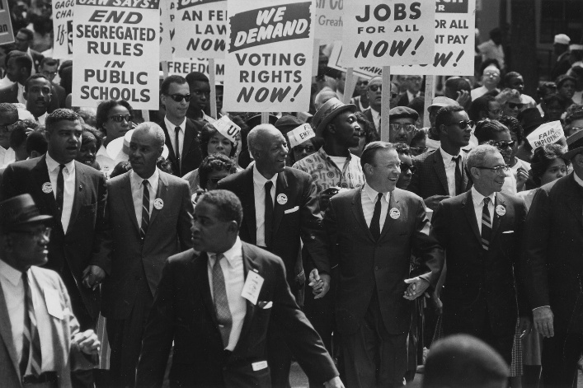
The period between 1954 and 1968 is often regarded as the most significant phase of the modern Civil Rights Movement. Activists used a variety of methods, including legal challenges, non-violent protest, boycotts, sit-ins and marches. The Montgomery Bus Boycott of 1955–56 demonstrated the effectiveness of organised protest and helped establish Martin Luther King Jr. as a national leader. Influenced by Christian teachings and the ideas of Mahatma Gandhi, King advocated non-violent direct action as a means of achieving change. During the 1960s, civil rights campaigns increasingly attracted national and international attention. Events such as the Birmingham Campaign, Freedom Rides, March on Washington and Selma Marches highlighted the realities of segregation and racial violence. Television coverage exposed discrimination to a wider audience and placed pressure on politicians to act. These campaigns contributed directly to the passage of the Civil Rights Act (1964), which outlawed segregation in public facilities, and the Voting Rights Act (1965), which removed many barriers to African American voting.
Despite these achievements, many African Americans became frustrated by the continued existence of poverty, poor housing and limited economic opportunities. Legal equality did not automatically result in social or economic equality. During the late 1960s, more radical movements emerged. Malcolm X criticised integrationist approaches and argued that African Americans should take greater control of their own communities. The Black Power movement emphasised racial pride, self-determination and economic independence. Organisations such as the Black Panther Party sought to address issues including police brutality, unemployment and poor housing conditions.
By 1992, African Americans had achieved substantial progress compared to their position in 1865. Segregation had been dismantled, voting rights had been protected and African Americans enjoyed far greater political representation. However, significant challenges remained. Many African Americans continued to experience economic disadvantage, educational inequalities and discrimination within the criminal justice system. Events such as the Los Angeles Riots of 1992 highlighted continuing racial tensions and demonstrated that the struggle for full equality remained unfinished.
The experience of African Americans between 1865 and 1992 therefore demonstrates both remarkable progress and persistent inequality. While constitutional rights and legal protections expanded significantly, historians continue to debate whether true equality had been achieved by the end of the period. The African American civil rights movement also provided inspiration and strategies for many other groups seeking greater rights and opportunities in the United States.
Trade Unions and Labour Rights
The campaign for workers' rights developed alongside the rapid industrialisation of the United States during the late nineteenth century. Between 1865 and 1992, workers sought improved wages, safer working conditions and greater influence over their employers. Throughout the period, tensions existed between organised labour, business interests and the federal government. Historians continue to debate whether workers achieved genuine civil rights gains or whether economic and political power remained firmly in the hands of employers.
Following the American Civil War (1861–65), the United States experienced unprecedented industrial growth. New technologies, expanding railroads and abundant natural resources transformed America into the world's leading industrial economy. Large corporations emerged in industries such as steel, oil, railroads and manufacturing. Industrial leaders including Andrew Carnegie, John D. Rockefeller and J. P. Morgan accumulated enormous wealth, while millions of workers laboured in factories, mines and railways for long hours and low wages. Workplace accidents were common, and there were few legal protections for employees.
As industrialisation expanded, workers increasingly turned to trade unions to defend their interests. Early labour organisations sought to unite workers in pursuit of improved conditions and greater bargaining power. The Knights of Labor became one of the first major national unions, accepting both skilled and unskilled workers. However, one of the most significant organisations was the American Federation of Labor (AFL) (1886), led by Samuel Gompers. Unlike earlier labour organisations, the AFL focused on practical objectives such as higher wages, shorter working hours and improved workplace safety rather than broader social reform. Employers and governments frequently opposed organised labour. During the late nineteenth century, both state and federal authorities often sided with business interests when industrial disputes occurred. The Great Railroad Strike (1877) demonstrated the willingness of the federal government to intervene against workers. Following wage cuts imposed by railroad companies, strikes spread across several states and disrupted national transport networks. President Rutherford B. Hayes deployed federal troops to restore order, resulting in violent clashes and numerous deaths. Similar patterns emerged during later disputes. The Haymarket Affair (1886) occurred when a bomb exploded during a labour demonstration in Chicago, killing police officers and civilians. Although responsibility for the bombing was never fully established, public opinion increasingly associated organised labour with radicalism and violence. The Homestead Strike (1892) further demonstrated tensions between workers and employers when striking steelworkers clashed with agents from the Pinkerton Detective Agency. The Pullman Strike (1894) again highlighted the limits of labour power. When workers protested wage reductions imposed by the Pullman Company, federal troops intervened on behalf of employers, helping to break the strike.
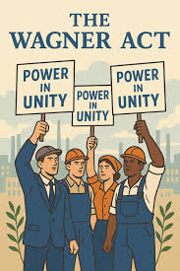
The early twentieth century brought some improvements for workers during the Progressive Era. Reformers sought to address social and economic problems created by industrialisation. However, significant gains remained limited until the economic crisis of the Great Depression (1929–39). The collapse of the American economy after Wall Street Crash (1929) led many Americans to question the traditional relationship between government and business. The presidency of Franklin D. Roosevelt marked a major turning point in labour history. Roosevelt's New Deal introduced unprecedented federal intervention in the economy and significantly strengthened organised labour. The National Labor Relations Act (Wagner Act) (1935) guaranteed workers the right to join trade unions and engage in collective bargaining. The legislation established the National Labor Relations Board (NLRB), which protected union rights and investigated unfair labour practices. As a result, union membership expanded rapidly throughout the 1930s and 1940s.
The Second World War (1939–45) further strengthened organised labour. High demand for industrial production increased employment opportunities and union membership reached record levels. By the end of the war, trade unions had become influential political and economic organisations capable of negotiating significant improvements in wages and working conditions. However, labour's position weakened after 1945. The growth of anti-communist sentiment during the Cold War contributed to suspicion of trade unions, particularly those associated with radical political movements. The Taft-Hartley Act (1947) restricted union activities by limiting strikes and permitting states to introduce "right-to-work" laws. Many historians view this legislation as evidence that government support for labour rights had begun to decline.
Economic changes during the 1970s and 1980s created additional challenges. The decline of manufacturing industries, increased international competition and the growth of the service sector reduced union membership. President Ronald Reagan's dismissal of striking air traffic controllers (1981) during the PATCO Strike was widely interpreted as a symbolic defeat for organised labour and encouraged employers to adopt a more confrontational approach towards unions.
By 1992 workers had achieved important gains, including improved wages, safer working conditions and legal recognition of collective bargaining. Nevertheless, organised labour exercised far less influence than it had during its post-war peak. Historians continue to debate whether the labour movement fundamentally transformed American society or whether business interests ultimately remained dominant throughout the period.

Native Americans
The experiences of Native Americans between 1865 and 1992 were shaped by conflict, dispossession, assimilation and resistance. Throughout the period, Native Americans faced attempts by the federal government to restrict tribal autonomy and integrate indigenous peoples into mainstream American society. Although significant progress was achieved by the late twentieth century, many Native communities continued to face substantial economic and social challenges.
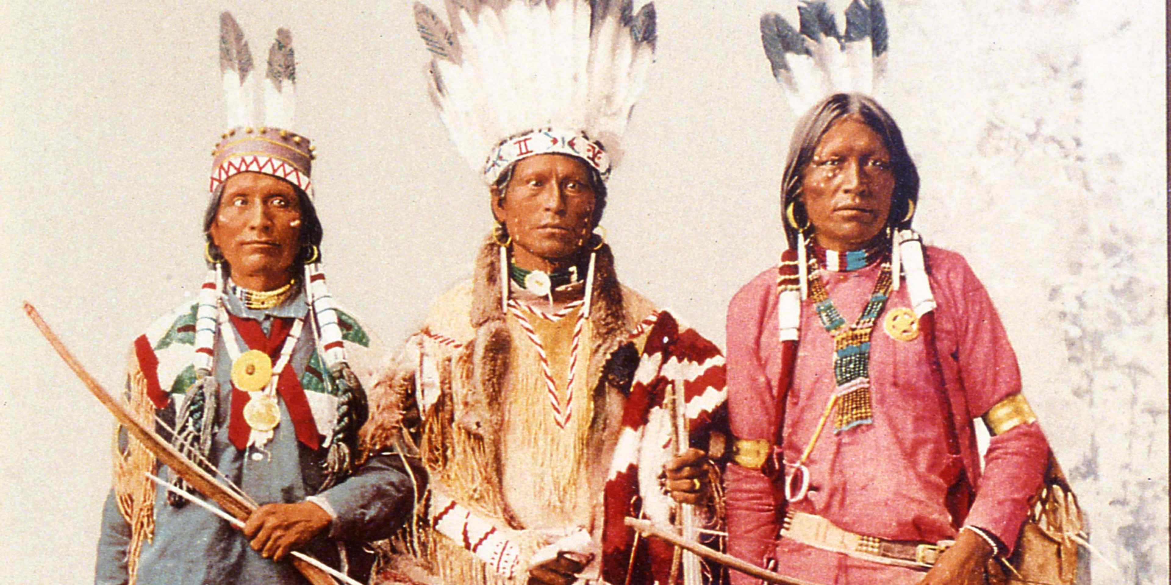
During the nineteenth century, westward expansion brought increasing conflict between Native American tribes and the federal government. Many white Americans believed in Manifest Destiny, the idea that the United States was destined to expand across the North American continent. As settlers moved westward, Native American communities were increasingly displaced from lands that had sustained them for generations. The federal government's response was often characterised by coercion and force. Native Americans were confined to reservations, frequently located on land unsuitable for traditional agricultural or hunting practices. Reservation policies undermined tribal independence and weakened traditional ways of life. At the same time, military campaigns were launched against tribes that resisted federal authority.
Several conflicts became symbolic of Native American resistance. The Battle of Little Bighorn (1876) saw forces led by Sitting Bull and Crazy Horse defeat the US Army under General George Custer. Although this represented a significant Native American victory, it ultimately prompted a stronger military response from the federal government. By the end of the nineteenth century, organised Native resistance had largely been defeated. The government's victory was symbolised by the Massacre at Wounded Knee (1890), where US troops killed approximately 300 Lakota Sioux men, women and children. Many historians regard Wounded Knee as marking the end of armed Native American resistance on the Great Plains.
Federal policy increasingly focused on assimilation rather than military conquest. The Dawes Act (1887) aimed to break up tribal communities by dividing communal land into individual allotments. Supporters believed this would encourage Native Americans to adopt white American farming practices and values. In reality, the policy resulted in the loss of millions of acres of Native land as surplus territory was sold to white settlers. Historians often regard the Dawes Act as one of the most damaging policies implemented against Native Americans. Assimilation policies extended beyond land ownership. Native American children were often sent to Boarding Schools, most famously the Carlisle Indian Industrial School, where they were discouraged or forbidden from speaking their native languages and practising traditional customs. These schools reflected the belief that Native cultures should be replaced by mainstream American values.
A significant shift occurred during the New Deal era. The Indian Reorganisation Act (1934), introduced under the leadership of John Collier, sought to reverse some aspects of assimilation policy. Tribal governments were encouraged, communal land ownership was protected and Native American cultural traditions received greater recognition. Nevertheless, poverty and discrimination remained widespread. Following the Second World War (1939–45), federal policy once again moved towards assimilation. The Termination Policy of the 1950s attempted to reduce federal responsibility for Native American affairs and encourage integration into mainstream society. Closely linked to this was the Relocation Programme, which encouraged Native Americans to move from reservations to urban areas in search of employment. Many Native Americans viewed these policies as a continuation of earlier efforts to undermine tribal sovereignty.
Inspired by the wider Civil Rights Movement, Native American activism expanded during the 1960s and 1970s. Organisations such as the American Indian Movement (AIM) (1968) campaigned against poverty, discrimination and the government's failure to honour treaty obligations. AIM leaders sought greater Native American control over education, housing and tribal affairs. The Occupation of Alcatraz (1969–71) became a powerful symbol of Native resistance. Activists occupied the abandoned island and argued that it should be returned to Native ownership under existing treaty provisions. The protest attracted national attention and highlighted Native American grievances. Similarly, the Occupation of Wounded Knee (1973) drew attention to corruption within tribal government and federal treatment of Native Americans. The 71-day standoff between AIM activists and federal authorities became one of the most significant moments in modern Native American protest.
Government attitudes gradually became more supportive during the 1970s. The policy of Self-Determination, promoted by President Richard Nixon, encouraged greater tribal control over local affairs. Legislation such as the Indian Self-Determination and Education Assistance Act (1975) strengthened tribal authority and reduced federal interference.
By 1992 Native Americans had achieved greater recognition of tribal sovereignty, cultural identity and legal rights. Federal policies increasingly recognised the importance of self-determination and tribal self-government. However, many Native communities continued to experience high levels of poverty, unemployment, poor health outcomes and educational disadvantage. As a result, historians often debate whether the progress achieved during the twentieth century fully compensated for the losses experienced during earlier periods of American expansion.

Women
The campaign for women's rights was one of the longest-running civil rights movements in American history. Between 1865 and 1992, women challenged political exclusion, economic discrimination and traditional social expectations. Although significant progress was achieved, debates continued over the extent to which genuine equality had been secured by the end of the period.
During the nineteenth century, women were largely excluded from public and political life. American society was heavily influenced by the ideology of "Separate Spheres", which suggested that men belonged in the public world of politics and employment while women were responsible for domestic and family life. Married women often possessed limited legal rights and had restricted access to higher education and professional careers.
The organised campaign for women's rights gained momentum during the mid-nineteenth century. Activists such as Elizabeth Cady Stanton and Susan B. Anthony argued that women should enjoy the same political rights as men. Building upon the ideas first expressed at the Seneca Falls Convention (1848) and the Declaration of Sentiments, suffrage became the central goal of the movement. Campaigners spent decades lobbying politicians, organising demonstrations and raising public awareness. These efforts eventually resulted in the passage of the 19th Amendment (1920), which granted women the right to vote throughout the United States. The achievement of suffrage represented a major turning point and demonstrated the effectiveness of long-term political activism. However, many historians argue that voting rights alone did not eliminate wider inequalities faced by women.
Economic opportunities remained limited during much of the early twentieth century. Women were often concentrated in lower-paid occupations and faced discrimination in hiring and promotion. Nevertheless, the Second World War (1939–45) created new opportunities. Millions of women entered factories, offices and defence industries while men served in the armed forces. The image of "Rosie the Riveter" symbolised women's contribution to the war effort and challenged assumptions about women's capabilities in the workplace. Despite these achievements, many women were encouraged to return to domestic roles after 1945. During the 1950s, ideals of suburban family life often emphasised marriage, motherhood and domestic responsibility. However, beneath this image of prosperity, many women remained dissatisfied with the limitations imposed upon them.
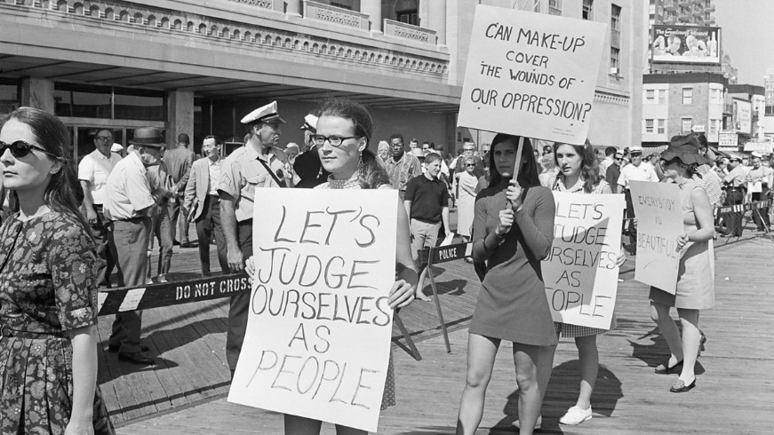
The publication of The Feminine Mystique (1963) by Betty Friedan became a catalyst for the modern women's movement. Friedan argued that many women experienced frustration and unfulfillment despite conforming to traditional expectations. Her work inspired a new generation of activists and contributed to the development of Second-Wave Feminism. The establishment of the National Organization for Women (NOW) (1966) provided a national platform for campaigning. Influenced by the wider Civil Rights Movement, feminists demanded equality in employment, education and politics. Activists increasingly challenged both legal discrimination and broader cultural attitudes towards gender roles. The federal government played an important role in advancing women's rights. The Equal Pay Act (1963) sought to reduce wage discrimination, while Title VII of the Civil Rights Act (1964) prohibited discrimination based on sex in employment. These measures provided legal mechanisms through which women could challenge unequal treatment.
The Supreme Court also contributed to changing opportunities for women. Roe v. Wade (1973) recognised a constitutional right to abortion and became one of the most significant legal victories of the women's movement. Supporters argued that reproductive freedom was essential for achieving equality, while opponents viewed the decision as morally unacceptable. The controversy surrounding Roe demonstrated the continuing divisions within American society regarding women's rights. Despite significant successes, the movement faced limitations. The proposed Equal Rights Amendment (ERA), designed to guarantee equality regardless of sex, failed to achieve ratification. Opposition led by Phyllis Schlafly and the STOP ERA Campaign demonstrated that many Americans remained resistant to feminist goals.
By 1992 women had achieved substantial advances in education, employment and political participation. Greater numbers of women entered universities, professional careers and public office than ever before. However, issues such as the Gender Pay Gap, underrepresentation in senior leadership positions and continuing debates about family roles suggested that full equality had not yet been achieved. Historians therefore continue to debate whether the period should be viewed primarily as an era of progress or as evidence of the persistence of gender inequality.

Task two: complete the table below

Group | Main Problems Faced | Main Achievements | Main Obstacles
African Americans | Segregation under Jim Crow laws; racial violence from groups such as the Ku Klux Klan; voting restrictions including literacy tests and poll taxes; discrimination in education, housing and employment. | 13th Amendment abolished slavery (1865); 14th Amendment granted citizenship (1868); 15th Amendment gave African American men voting rights (1870); Civil Rights Act (1964); Voting Rights Act (1965); growing political participation and legal equality. | White resistance in the South; Supreme Court ruling in Plessy v. Ferguson (1896); continued discrimination and inequality despite legal advances.
Trade Unions
Native Americans
Women

