
Department of Economics
Economics Year 12 --> Year 13 Bridging Work

Preparation for the coming year is vital to your success. Department of Economics would like you all to succeed in and get ready for year 13. Ensure that you have fully revised Year 12 content
Complete the following tasks as revision but also to support your understanding of the more difficult topics.

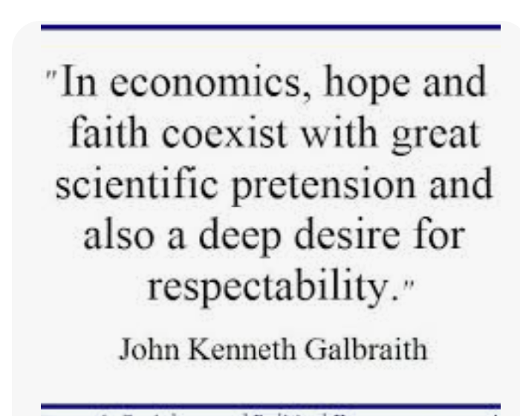

Task 1:
Watch the following video-
https://wetheeconomy.com/films/globalization-who-cares-you-do/
Answer the following questions:
- What is globalisation?
- Why might globalisation led to lower price levels for other countries?
- How might globalisation increase consumer choice?

Task 2 :
Research the African Continental Free Trade Area. (TFTA)
Answer the following questions:
- What countries are involved?
- How can this increase the rate of economic growth for countries within the free trade area?
- How can this increase the employment rates for these countries?
- What is a tariff?
- Why will the removal of tariffs between these countries reduce the prices of goods and services?

Task 3:
CMA and competition: using the link below and research of your own, explain why the CMA blocked the merger between Sainsbury’s and ASDA.
https://www.gov.uk/government/news/cma-blocks-merger-between-sainsburys-and-asda
Answer the following questions:
- How could the merger bring cheap prices to consumers – consider EoS.
- How could the merger increase consumer choice?
- How could the merger increase investment for firms?
Eval:
- How could the merger lead to higher prices for consumers?
- How could the merger lead to less choice for consumers?
- How could the merger cause other competitors to exit the market.

Task 4:
Answer the following questions first and then watch the video:
https://www.bbc.co.uk/iplayer/episode/p02l52fy/caribbean-with-simon-reeve-episode-2
1. Identify 2 reasons why Venezuela should be ‘one of the world’s richest countries’?
2. Extension: Which other countries have large oil reserves? Think before you click!
https://www.visualcapitalist.com/map-countries-most-oil-reserves/

3. Why Venezuela’s GDP per capita might not be as high as expected (given the oil reserves)? You will find out some possible answers as you watch the video.
•
•
•

4. Throughout the video, there are lots of examples of Venezuela’s worsening living standards. You can come back to this question as you go along. Applying your knowledge is a key skill for economics students.
• 1 in 3 Venezuelans are poor
•
•
•
•
•
5. Simon comments that ‘wealth is in the hands of the few in Venezuela’. Watch how economists measure inequality using Lorenz curves/Gini coefficient’
https://www.youtube.com/watch?v=ns9f2FOc26M
Think about what it means for a country to have high levels of inequality and the impact it has on society. Is inequality inevitable in (free market) economies?

6. 32min20 Some of the reasons given for Venezuela’s economic decline are given as ‘restrictions on foreign currency meaning that businesses don’t want to import and ‘Soviet-style’ controls on prices meaning that shops don’t want to sell.

7. 33min 20 How much does it cost to fill a tank of petrol? How does this compare to your local petrol station? What reasons are given for why petrol is so cheap?

8. How does this government policy (in question 8) lead to a more unequal distribution of income in Venezuela?
9. 34 min 45 seconds. Simon visits a family living with an oil pump outside their house. What problems have the family suffered/witnessed as a result?

10. 36min 15 seconds. Petrol in Columbia costs 100 times the price in Venezuela and large numbers of people illegally smuggle petrol at the border. Explain the impact of this smuggling on the Venezuelan economy. Consider the impact of the lost tax revenue? How does it change the incentives for the taxi driver to seek work?

Task 5: Financial Crisis
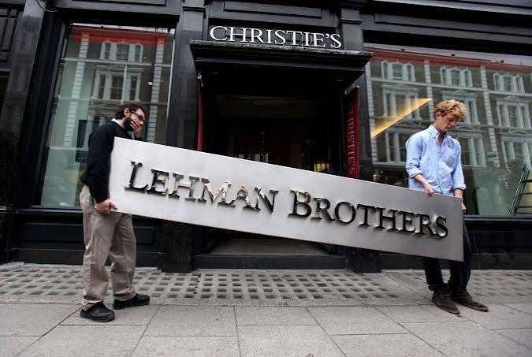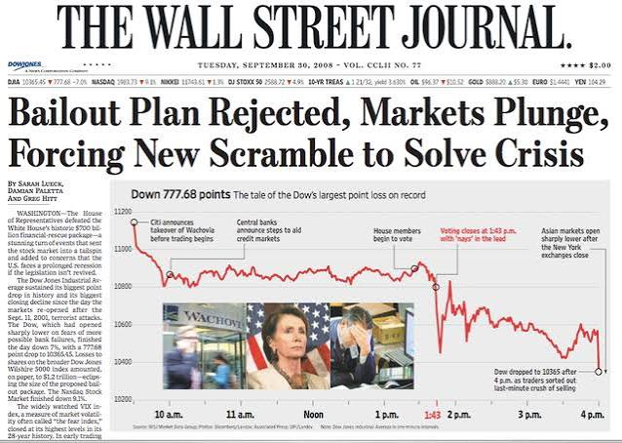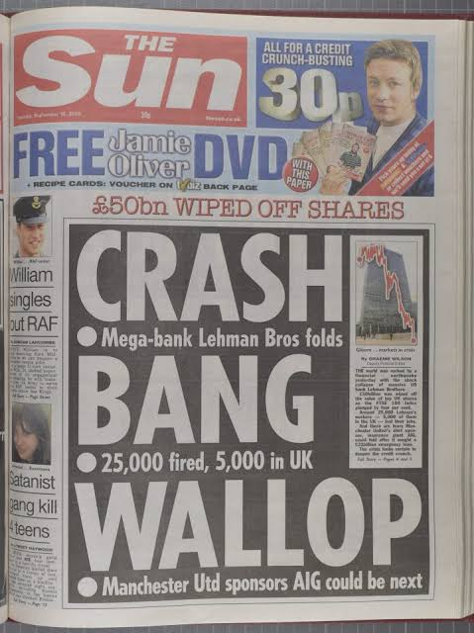
The 2008 financial crisis was the most severe global economic downturn since the Great Depression. Triggered by the bursting of the United States housing bubble, it caused a catastrophic collapse of major financial institutions, a frozen global credit market, and the resulting "Great Recession".Financial markets are essential to modern economies—but when they fail, the consequences can be enormous.
Produce a timeline of 2008 financial crisis showing at least 8 key events. Include:
- Dates
- Key organisations
- Important decisions
- Government actions
Who was affected?
Consider
- households
- firms
- banks
- governments
- taxpayers
- investors
How did governments respond?
Research:
- Bank bailouts
- Interest rate changes
- Quantitative easing
- Fiscal policy and regulation
You can write notes on the above or make a poster or mind map

