Transition work Year 11 to 12 ART and DT

These two study activities are designed to ensure you have a broad appreciation of the work of designers by the time you join the group in September.

Study activity 1.
Go to a museum of Art and/or design
Such as;
The William Morris Museum
The V and A – Stratford or Kensington
Perhaps a museum when you are away
If you are interested in architecture, you can visit an important building that is open to the public, such as 2 Willow road – which is a National Trust house, or the Queen Elizabeth hunting lodge in Chingford, which is a great example of an early timber-framed building.

Create a double A3 paged spread on an exhibition or a piece of artwork or design – there are free exhibitions as well as ones that require an entry fee. Complete your pages with good presentation and include images alongside studies of works (where you make a drawn copy) and also write up

Critique the exhibition and or piece of art/design, using these prompts,
Intentions
(What is the purpose of the work/exhibition? How does the artist/museum curator intend the viewer to get from the work/exhibition?)
The purpose of this work/exhibition appears to be to encourage viewers to think about...
The artist/curator seems to intend for the audience to reflect on...
Through the use of ______, the exhibition aims to communicate...
One of the main intentions behind this work is to highlight...
The artist/curator invites viewers to engage with the theme of...

Knowledge
(Write in detail what you have learned from what you have read while in the museum.)
From the information provided in the exhibition, I learned that...
The museum text helped me understand the historical/cultural significance of...
One interesting fact I discovered while reading the displays was...
The exhibition expanded my knowledge of ______ by explaining...
After reading the exhibition materials, I gained a deeper understanding of...

Understanding
(What have you taken away as understanding from this exhibition?)
This exhibition helped me understand that...
After experiencing the exhibition, I now have a greater appreciation for...
The key message I took away from this exhibition is...
My understanding of ______ changed because the exhibition showed...
Reflecting on the exhibition, I realised that...

Study Activity 2
Read the following phrases and think about what they mean,

“Design is not art. Design has to function.”
“Art is meant to provoke thought and emotions, but it doesn’t solve problems.”
“Artists primarily work off instinct, whereas designers employ a methodical, data-driven process.”

Do you agree with these statements? Write a short paragraph which says what you feel about these statements. Do they ring true to you or can they be challenged?

Find 4 examples of art/design pieces that you think demonstrate these statements being challenged. Either all the statements being challenged in a piece, or one statement being challenged. As long as you are detailed in your explanation, it’s not important whether you address all the statements with each example you find. Present your thoughts alongside an image of the art/design piece you’re focussing on.

Study Activity 3
What is postmodernist art and or design? What did post modernist artists/ designers find wrong with modernist art/design that they sought to create a new style to challenge the modernist concepts of design?
Research and find examples of postmodernist work and compare it to examples of modernist work. Use your research from the first task to describe differences you see in the pieces. Look at the statements again from activity 2 and apply these to your thoughts on the post modern design pieces you’ve found in your research.
Also a double-paged spread please on A3
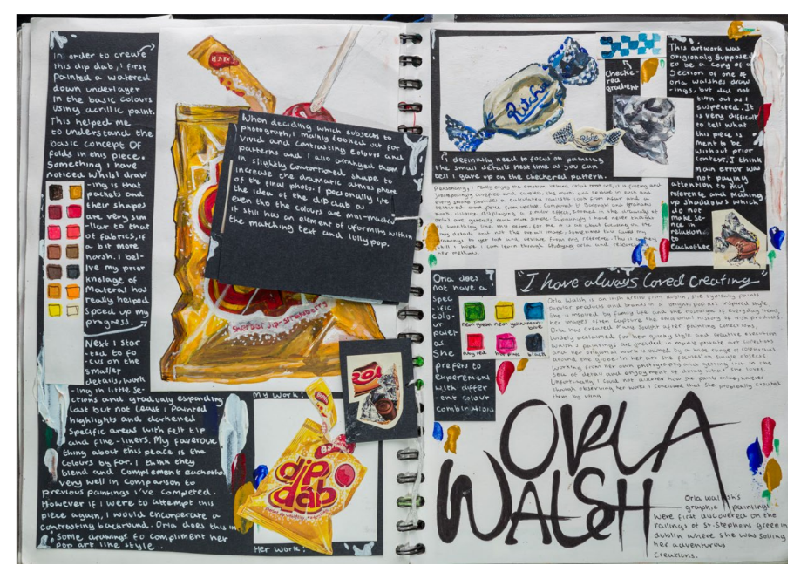
Example above of a research page of an artist, with critique and student studies. Students can do the same for a piece on design.

